**GAUTAM BUDDHA**

**UNIVERSITY**

**DEPARTMENT OF INFORMATION AND COMMUNICATION TECHNOLOGY**



**Cloud Computing LabManual (IT306)**

**SUBMITTED TO SUBMITTED BY**

Prof.Vaishnavi Priyadarshani Aditya Aggarwal

(18/BIT/004)

**INDEX**

|  |  |  |  |
| --- | --- | --- | --- |
| **SNo.** | **Name of Experiment** | **Date** | **Page**  **No.** |
| 1. | Understand deployment models, service models, advantages of cloud computing. | 05/02/21 | 3 |
| 2. | Install VirtualBox/VMware Workstation with different flavours of Linux or Windows OS on top of windows 7 or 8 or 10. | 18/02/21 | 9 |
| 3. | Install a C compiler in the virtual machine created using virtual box and execute Simple Programs. | 05/03/21 | 27 |
| 4. | Install Google Cloud SDK in your Virtual Box in any flavour of Linux. | 19/03/21 | 31 |
| 5. | Create a Hello World File on Commercial Cloud Technology: Google Cloud Platform | 07/04/21 | 34 |
| 6. | Install Google App Engine. Create Hello World App and other simple Web Applications using Python/Java. | 17/04/21 | 40 |
| 7. | Use Google Application Engine (GAE) Launcher to launch the Web Applications. | 17/04/21 | 44 |
| 8. | Implement IaaS using your resources. Technology: OpenStack | 17/04/21 | 49 |
| 9. | Virtualization: understand different types of Virtualization and Hypervisors. | 24/04/21 | 55 |
| 10. | Understanding Cloud Security, Data Dictionary and Web Server Security. | 24/04/21 | 62 |
| 11. | Case Study of Amazon Web Services. | 24/04/21 | 66 |
| 12. | Identity Management in Cloud Concept: Simulate identity management in your private cloud. Technology: Own Cloud | 28/04/21 | 73 |
| 13. | Storage as a Service: To explore Storage as a service for remote file access using web interface. Technology: Own Cloud | 19/05/21 | 81 |
| 14. | Platform as a Service: To Deploy web applications on commercial cloud. Technology: Google App Engine | 29/05/21 | 88 |
| 15. | Amazon Web Service: To create and access VM instances and demonstrate various | 02/06/21 | 100 |

**EXPERIMENT-1**

**OBJECTIVE**

Understand deployment models, service models, advantages of cloud computing.

**REQUIREMENTS**

Any Operating System and any Browser

**THEORY**

Cloud Computing means storing and accessing data and programs over the internet instead of your computer's hard drive. The "cloud" is just a metaphor for the internet. It goes back to the days of flowcharts and presentations that would represent the gigantic server-farm infrastructure of the internet as nothing but a puffy cloud, accepting connections and doling out information as it floats. Cloud computing has two meanings. The most common refers to running workloads remotely over the internet in a commercial provider’s data centre, also known as the “public cloud” model. Popular public cloud offerings—such as Amazon Web Services (AWS), Salesforce’s CRM system, and Microsoft Azure—all exemplify this familiar notion of cloud computing. Today, most businesses take a multi-cloud approach, which simply means they use more than one public cloud service. The second meaning of cloud computing describes how it works: a virtualized pool of resources, from raw compute power to application functionality, available on demand. When customers procure cloud services, the provider fulfils those requests using advanced automation rather than manual provisioning.

**Characteristics of Cloud Computing**

1. **Agility:** The cloud works in a distributed computing environment. It shares resources among users and works very fast.
2. **High availability and reliability:** The availability of servers is high and more reliable because the chances of infrastructure failure are minimum.
3. **High Scalability:** Cloud offers "on-demand" provisioning of resources on a large scale, without having engineers for peak loads.
4. **Multi-Sharing:** With the help of cloud computing, multiple users and applications can work more efficiently with cost reductions by sharing common infrastructure.
5. **Device and Location Independence:** Cloud computing enables the users to access systems using a web browser regardless of their location or what device they use e.g., PC, mobile phone, etc. As infrastructure is off-site (typically provided by a third-party) and accessed via the Internet, users can connect from anywhere.
6. **Maintenance:** Maintenance of cloud computing applications is easier, since they do not need to be installed on each user's computer and can be accessed from different places. So, it reduces the cost also.
7. **Low Cost:** By using cloud computing, the cost will be reduced because to take the services of cloud computing, IT company need not to set its own infrastructure and pay-as-per usage of resources.
8. **Services in the pay-per-use mode:** Application Programming Interfaces (APIs) are provided to the users so that they can access services on the cloud by using these APIs and pay the charges as per the usage of services.

**Cloud Deployment Models**

Cloud deployment models are categorized into four different categories:

* **Public Cloud:**

Public cloud is open to all to store and access information via the Internet using the pay-per-usage method. In public cloud, computing resources are managed and operated by the Cloud Service Provider (CSP).

**Advantages of Public Cloud**

* Public cloud is owned at a lower cost than the private and hybrid cloud.
* Public cloud is maintained by the cloud service provider, so do not need to worry about the maintenance.
* Public cloud is easier to integrate. Hence it offers a better flexibility approach to consumers.
* Public cloud is location independent because its services are delivered through the internet.
* Public cloud is highly scalable as per the requirement of computing resources.
* It is accessible by the general public, so there is no limit to the number of users.

**Disadvantages of Public Cloud**

* Public Cloud is less secure because resources are shared publicly.
* Performance depends upon the high-speed internet network link to the cloud provider.
* The Client has no control of data.
* **Private Cloud:**

Private Cloud is also known as and internal cloud or corporate cloud. It is used by organizations to build and manage their own data centres internally or by the third party. It can be deployed using Opensource tools such as Openstack and Eucalyptus. Based on the location and management, National Institute of Standards and Technology (NIST) divide private cloud into the following two parts-

1. On-premise private cloud
2. Outsourced private cloud

**Advantages of Private Cloud**

* Private cloud provides a high level of security and privacy to the users.
* Private cloud offers better performance with improved speed and space capacity.
* It allows the IT team to quickly allocate and deliver on-demand IT resources.
* The organization has full control over the cloud because it is managed by the organization itself. So, there is no need for the organization to depends on anybody.
* It is suitable for organizations that require a separate cloud for their personal use and data security is the first priority.

**Disadvantages of Private Cloud**

* Skilled people are required to manage and operate cloud services.
* Private cloud is accessible within the organization, so the area of operations is limited.
* Private cloud is not suitable for organizations that have a high user base, and organizations that do not have the prebuilt infrastructure, sufficient manpower to maintain and manage the cloud.
* **Hybrid Cloud:**

Hybrid Cloud is a combination of the public cloud and the private cloud. we can say:

Hybrid Cloud = Public Cloud + Private Cloud

Hybrid cloud is partially secure because the services which are running on the public cloud can be accessed by anyone, while the services which are running on a private cloud can be accessed only by the organization's users.

Example: Google Application Suite (Gmail, Google Apps, and Google Drive), Office 365 (MS Office on the Web and One Drive), Amazon Web Services.

**Advantages of Hybrid Cloud**

* Hybrid cloud is suitable for organizations that require more security than the public cloud.
* Hybrid cloud helps you to deliver new products and services more quickly.
* Hybrid cloud provides an excellent way to reduce the risk.
* Hybrid cloud offers flexible resources because of the public cloud and secure resources because of the private cloud.

**Disadvantages of Hybrid Cloud**

* In Hybrid Cloud, security feature is not as good as the private cloud.
* Managing a hybrid cloud is complex because it is difficult to manage more than one type of deployment model.
* In the hybrid cloud, the reliability of the services depends on cloud service providers.
* **Community Cloud:**

Community cloud allows systems and services to be accessible by a group of several organizations to share the information between the organization and a specific community. It is owned, managed, and operated by one or more organizations in the community, a third party, or a combination of them. Example: Health Care community cloud

**Advantages of Community Cloud**

* Community cloud is cost-effective because the whole cloud is being shared by several organizations or communities.
* Community cloud is suitable for organizations that want to have a collaborative cloud with more security features than the public cloud.
* It provides better security than the public cloud.
* It provides collaborative and distributive environment.
* Community cloud allows us to share cloud resources, infrastructure, and other capabilities among various organizations.

**Disadvantages of Community Cloud**

* Community cloud is not a good choice for every organization.
* Security features are not as good as the private cloud.
* It is not suitable if there is no collaboration.
* The fixed amount of data storage and bandwidth is shared among all community members.

**Cloud Service Models:**

Cloud service models are categorized into three different categories:

* **Infrastructure as a Service:**

IaaS is also known as Hardware as a Service (IaaS). It is a computing infrastructure managed over the internet. The main advantage of using IaaS is that it helps users to avoid the cost and complexity of purchasing and managing the physical servers.

**Characteristics of IaaS**

* Resources are available as a service
* Services are highly scalable
* Dynamic and flexible
* GUI and API-based access
* Automated administrative tasks

Example: DigitalOcean, Linode, Amazon Web Services (AWS), Microsoft Azure,

Google Compute Engine (GCE), Rackspace, and Cisco Metacloud.

* **Platform as a Service:**

PaaS cloud computing platform is created for the programmer to develop, test, run, and manage the applications.

**Characteristics of PaaS**

* Accessible to various users via the same development application.
* Integrates with web services and databases.
* Builds on virtualization technology, so resources can easily be scaled up or down as per the organization's need.
* Support multiple languages and frameworks.
* Provides an ability to “Auto-scale ".

Example: AWS Elastic Beanstalk, Windows Azure, Heroku, Force.com, Google App Engine, Apache Stratos, Magento Commerce Cloud, and OpenShift.

* **Software as a Service:**

SaaS is also known as "on-demand software". It is a software in which the applications are hosted by a cloud service provider. Users can access these applications with the help of internet connection and web browser.

**Characteristics of SaaS**

* Managed from a central location
* Hosted on a remote server
* Accessible over the internet
* Users are not responsible for hardware and software updates. Updates are applied automatically.
* The services are purchased on the pay-as-per-use basis

Example: BigCommerce, Google Apps, Salesforce, Dropbox, ZenDesk, Cisco WebEx, Slack, and GoToMeeting

**RESULT**

In this experiment, we have discussed about cloud computing and its characteristics, advantages and disadvantages as well as deployment model and service model.

**EXPERIMENT-2**

**OBJECTIVE**

Install VirtualBox/VMware Workstation with different flavours of Linux or Windows OS on top of windows 7 or 8 or 10.

**REQUIREMENTS**

VirtualBox Setup, VMware Workstation Setup, an ISO File (ubuntu).

**Procedure to Install**

**Steps to Install VMware Workstation**

1. Download Link

Link for downloading the software is <https://www.vmware.com/products/workstation-pro/workstation-pro-evaluation.html> . Download the software for windows. Good thing is that there is no signup process.

Click and download begins. Software is around 541 MB.

2. Download the installer file

It should probably be in the download folder by default, if you have not changed the settings in your browser. File name should be something like VMware-workstation-full-15.5.1-15018445.exe. This file name can change depending on the version of the software currently available for download. But for now, till the next version is available, they will all be VMware Workstation 15 Pro.

3. Locate the downloaded installer file

For demonstration purpose, I have placed the downloaded installer on my desktop. Find the installer on your system and double click to launch the application.

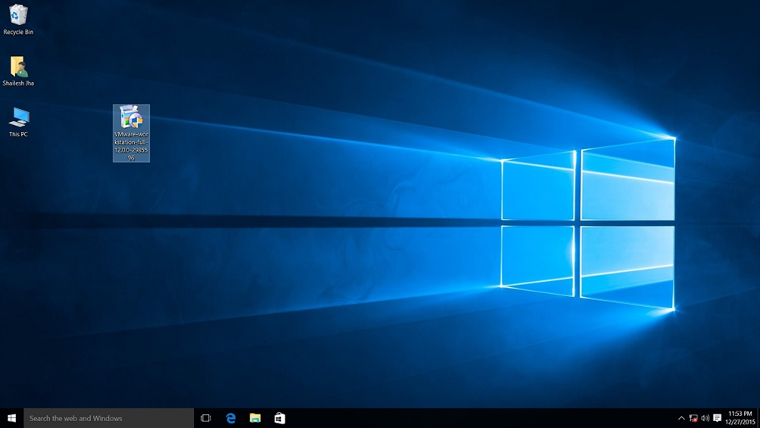

4. User Access Control (UAC) Warning

Now you should see User Access Control (UAC) dialog box. Click yes to continue.

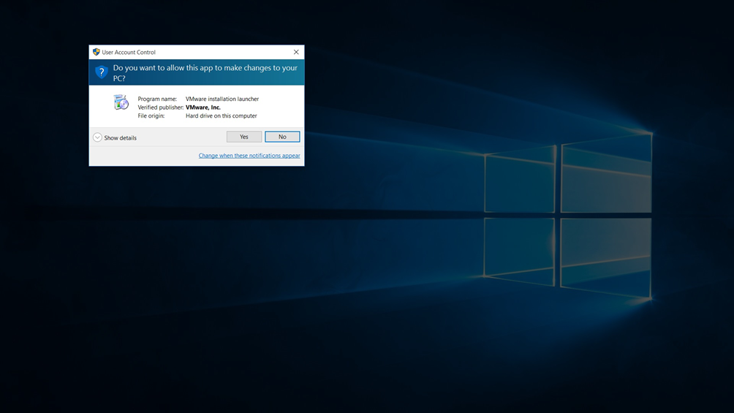

Initial Splash screen will appear. Wait for the process to complete.

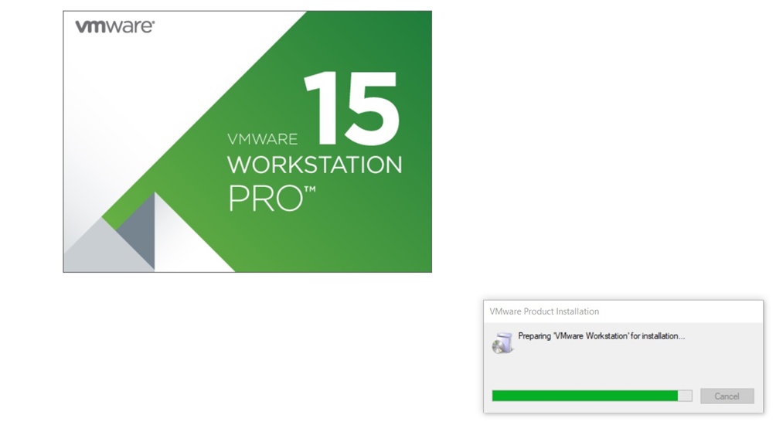

5. VMware Workstation Setup wizard

Now you will see VMware Workstation setup wizard dialog box. Click next to continue.

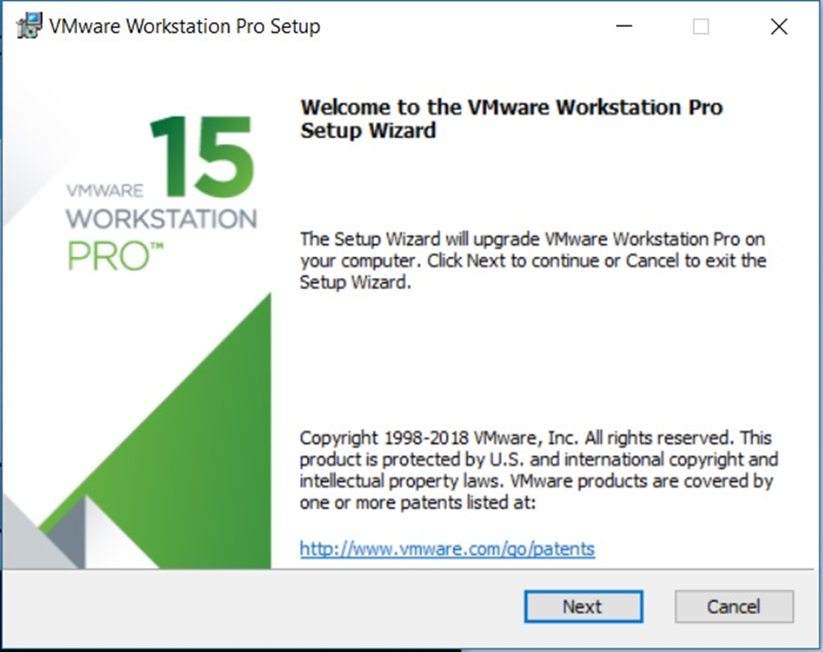

6. End User Licence Agreement

This time you should see End User Licence Agreement dialog box. Check “I accept the terms in the Licence Agreement” box and press next to continue.

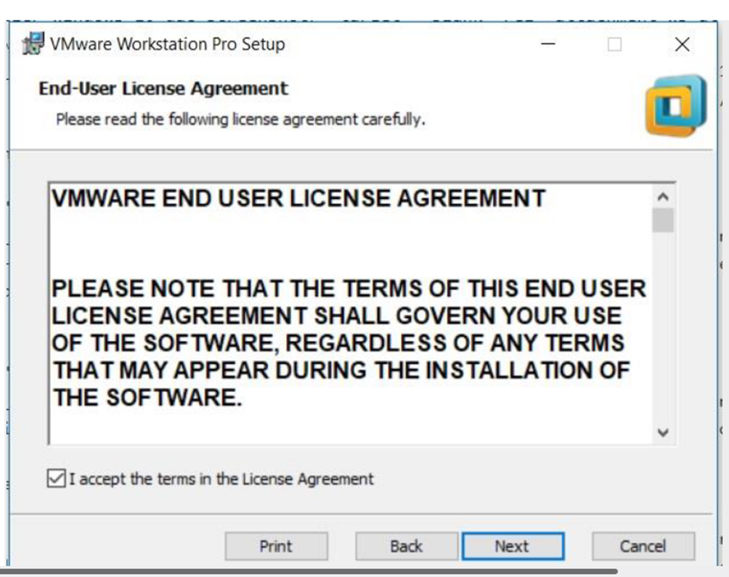

7. Custom Setup options

Select the folder in which you would like to install the application. There is no harm in leaving the defaults as it is. Also select Enhanced Keyboard Driver check box.

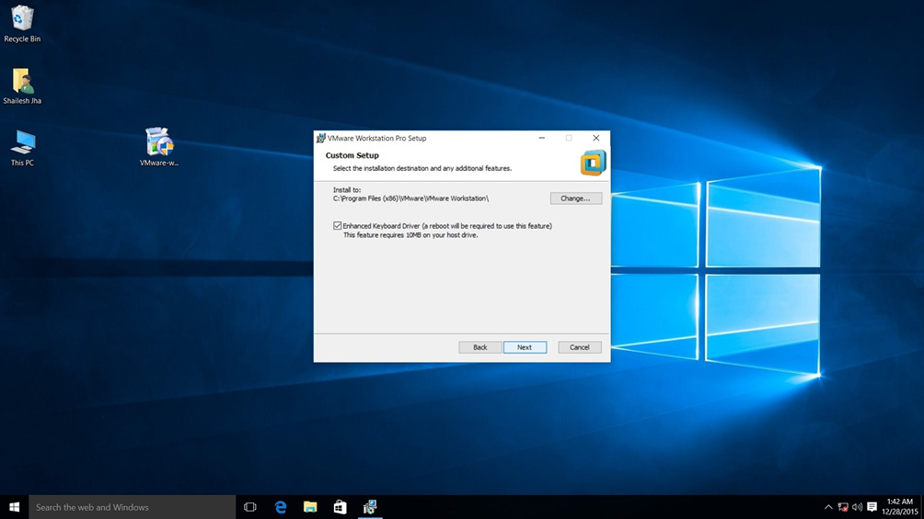

8. User Experience Settings

Next you are asked to select “Check for Updates” and “Help improve VMware Workstation Pro”. Do as you wish. I normally leave it to defaults that is unchecked.

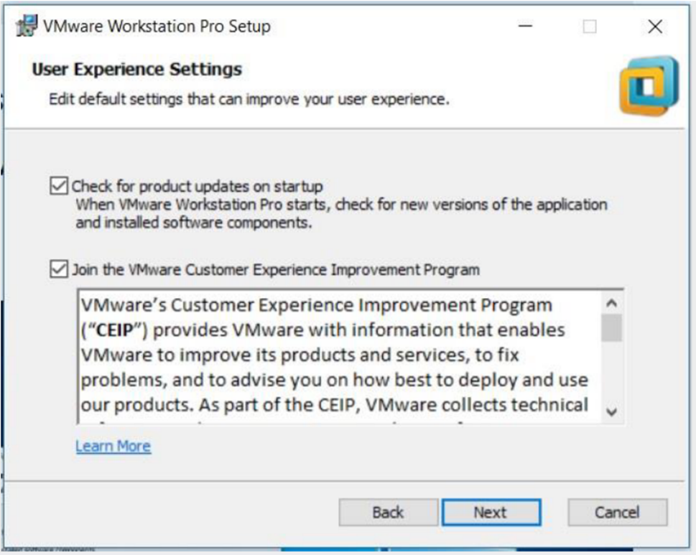

9. Application Shortcuts preference

Next step is to select the place you want the shortcut icons to be placed on your system to launch the application. Please select both the options, desktop and start menu and click next.

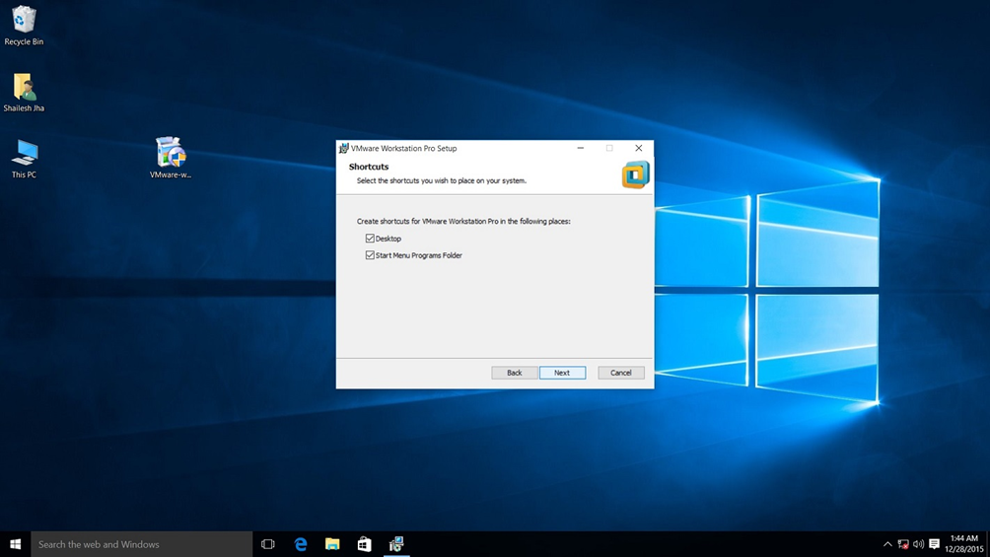

10. Installation begins

Now you see the begin installation dialog box. Click install to start the installation process.

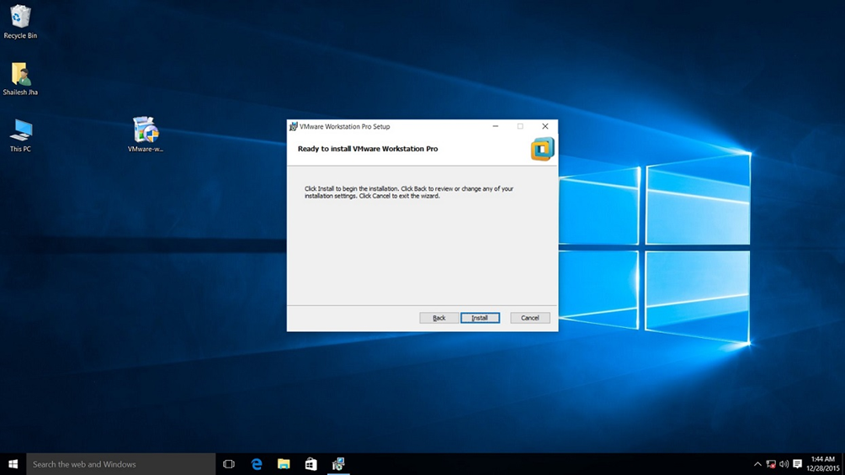

Below screenshot shows Installation in progress. Wait for this to complete.

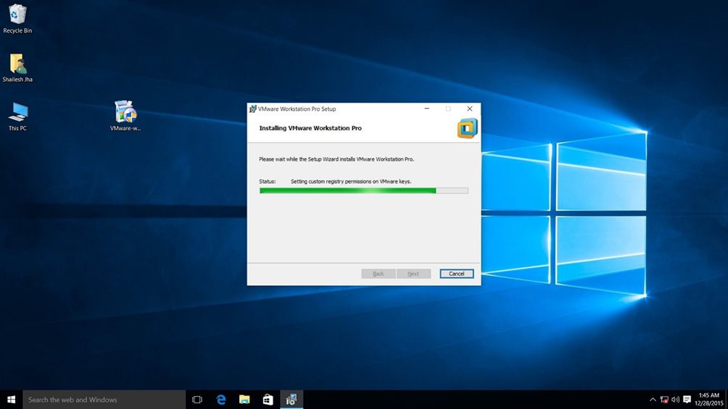

At the end you will see installation complete dialog box. Click finish and you are done with the installation process. You may be asked to restart your computer. Click on Yes to restart.

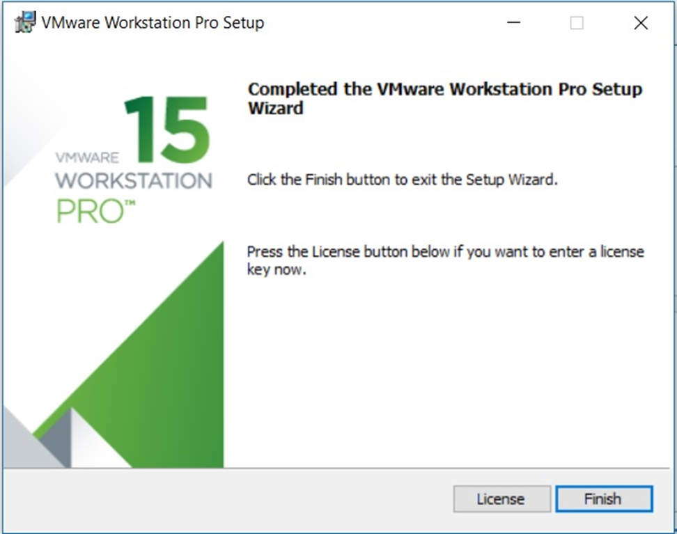

11. Launch VMware Workstation

After the installation completes, you should see VMware Workstation icon on the desktop. Double click on it to launch the application.



12. Licence Key

If you see the dialog box asking for licence key, click on trial or enter the licence key. Then what you have is the VMware Workstation 15 Pro running on your windows 10 desktop. If don’t have the licence key, you will have 30 days trial.

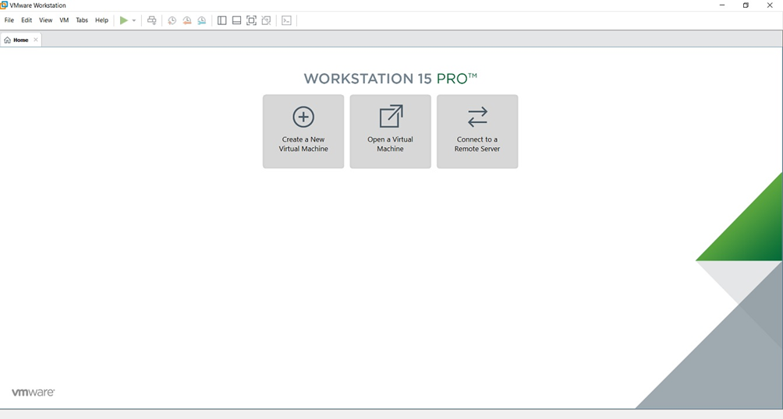

13. At some point if you decide to buy

At some point of time if you decide to buy the Licence key, you can enter the Licence key by going

to Help->Enter a Licence Key

You can enter the 25-character licence key in the dialog box shown below and click OK. Now you have the licence version of the software.

**Steps to Install VirtualBox**

1. Visit http://www.virtualbox.org/wiki/downloads

2. Download VirtualBox platform packages for your OS

3. Open the Installation Package by double clicking

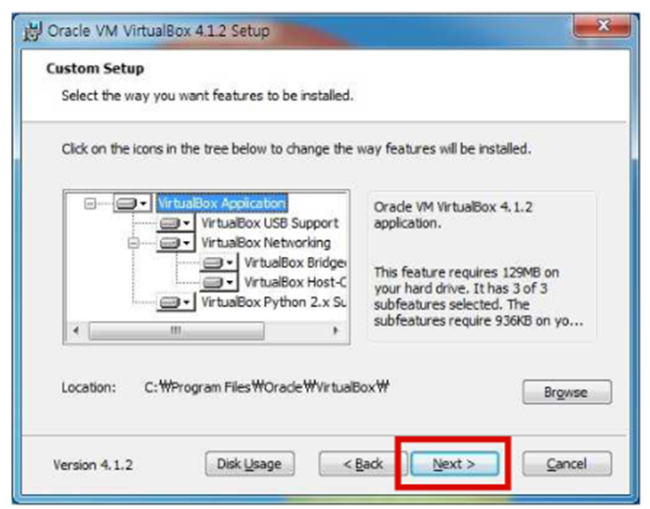

4. Click continue and finish installing VirtualBox

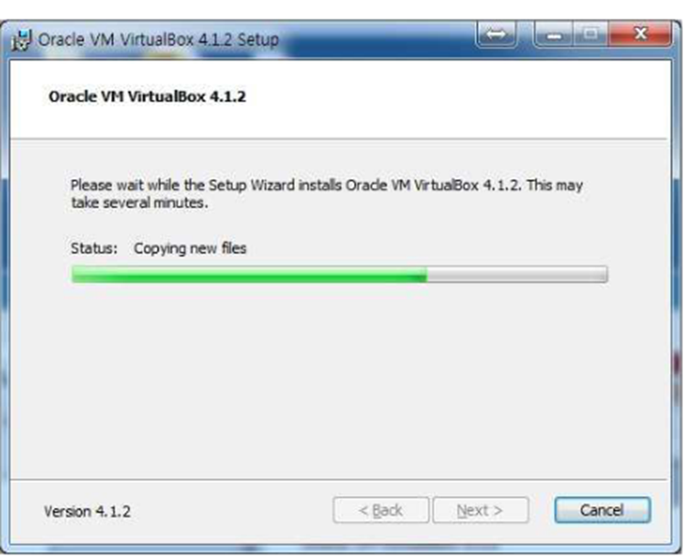

5. When finished installation, close the window.

**Steps to Download Linux (Ubuntu)**

1. Visit the page

<http://www.ubuntu.com/download/ubuntu/download>

2. Choose the Latest version of Ubuntu and 32-bit and click “Start Download”

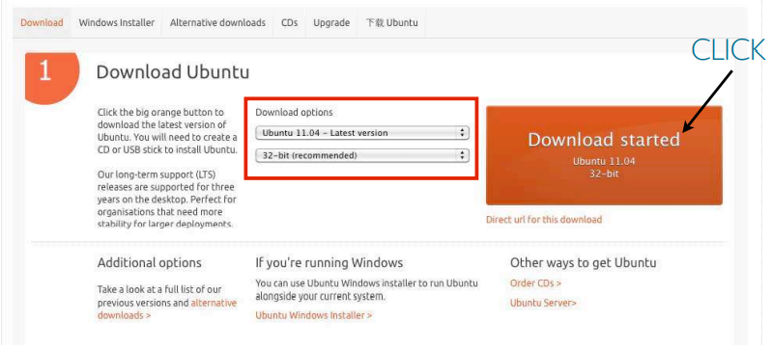

**Steps to Install Linux (Ubuntu) using VirtualBox**

1. Run VirtualBox by double-clicking the icon

2. Click “New” button on the top left corner

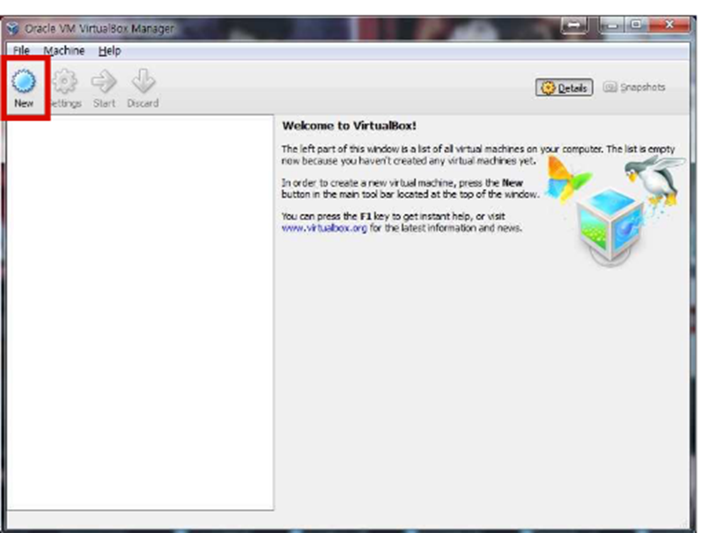

3. Click “Continue” on the pop-up window

4. Type VM name, select “Linux” for the OS and choose “Ubuntu” for the version.

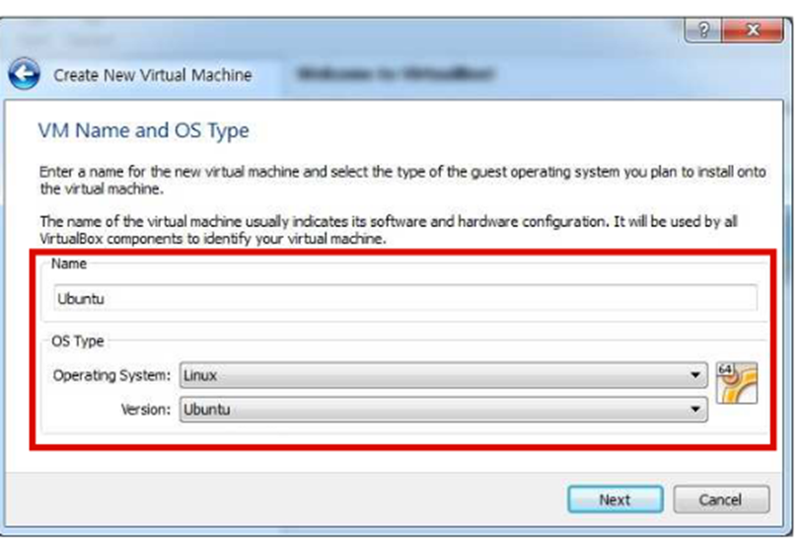

5. Choose the amount of memory to allocate (I suggest choosing between 512 MB to 1024 MB)

6. Click Continue or Next

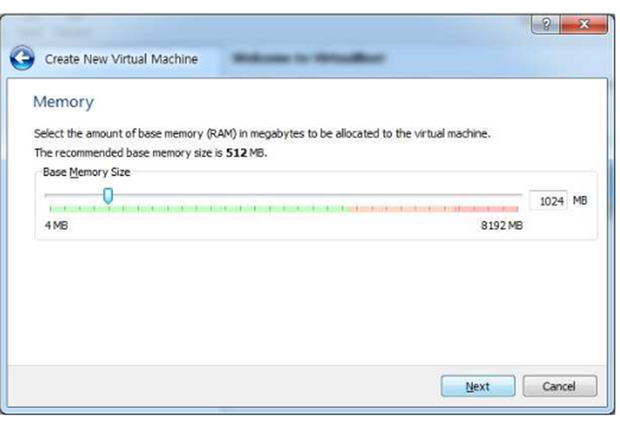

7. Choose create a new virtual hard disk

8. Click Continue or Next

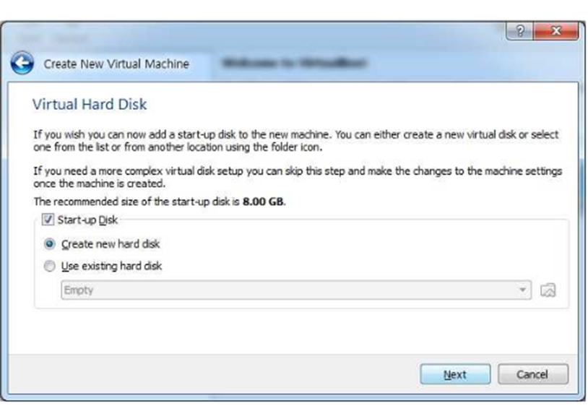

9. Choose VDI (VirtualBox Disk Image)

10. Click Continue or Next

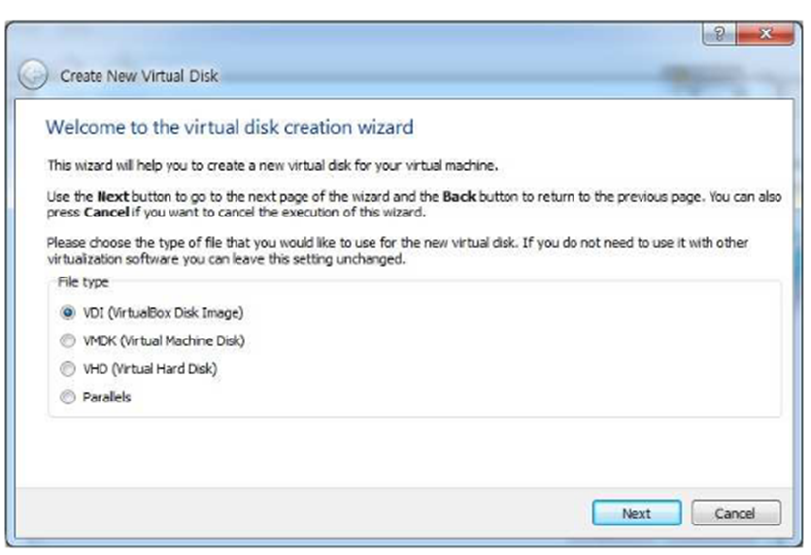

11. Choose “Dynamically Allocated” click continue. This way, the size of your Virtual Hard Disk will grow as you use.

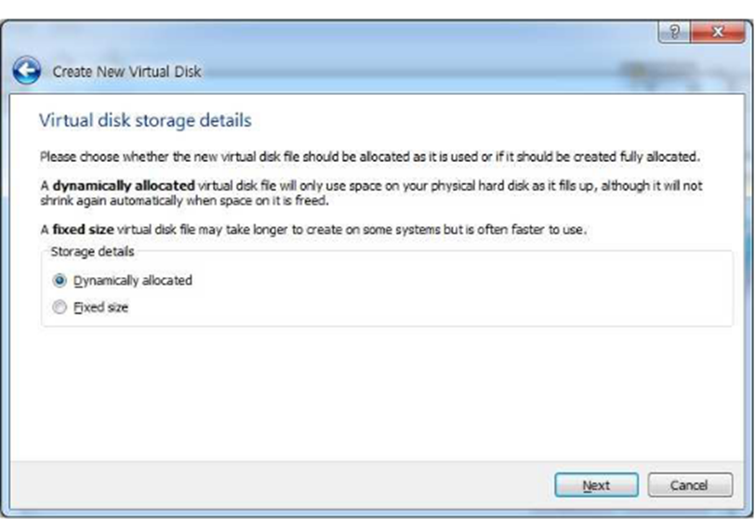

12. Click the folder icon and choose the ubuntu iso file you downloaded.

13. Select the size of the Virtual Disk (I recommend choosing 8 GB) and click continue

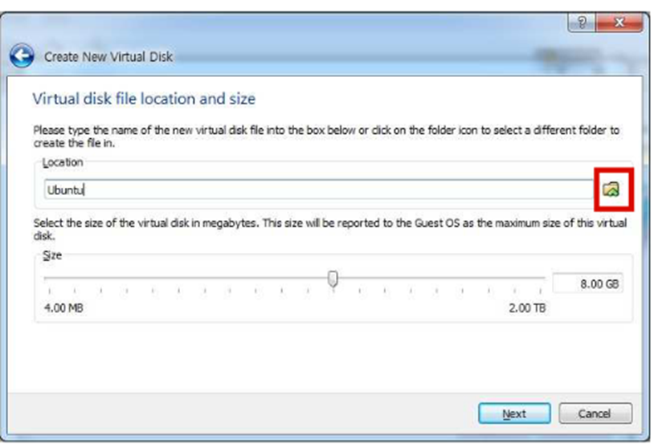

14. Click Create

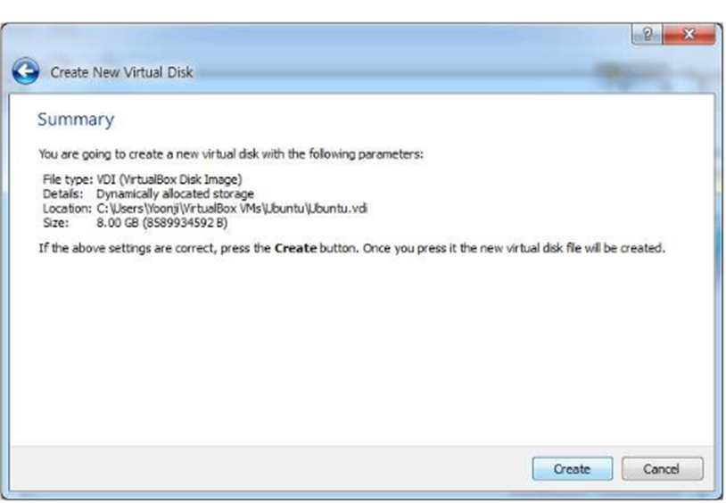

**Steps for Running Linux (Ubuntu)**

1. Choose Ubuntu from left column and click Start

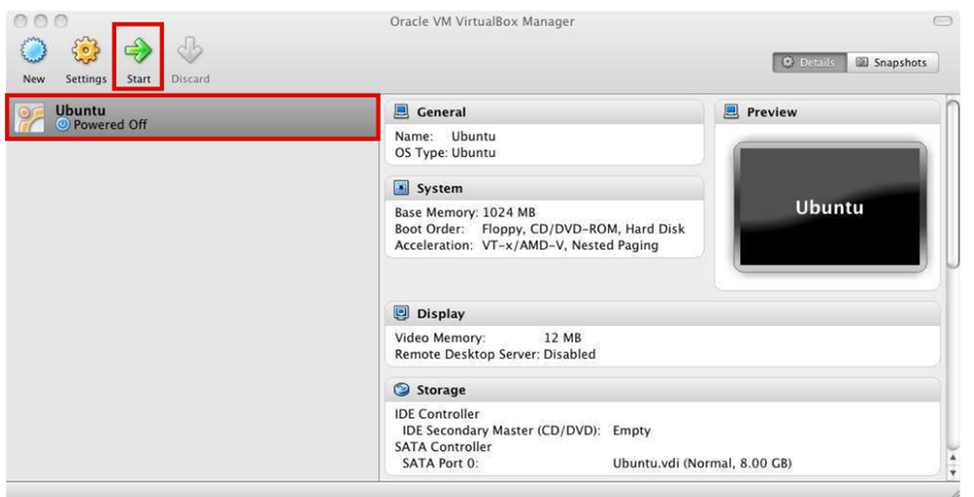

2. Click continue on pop-up window

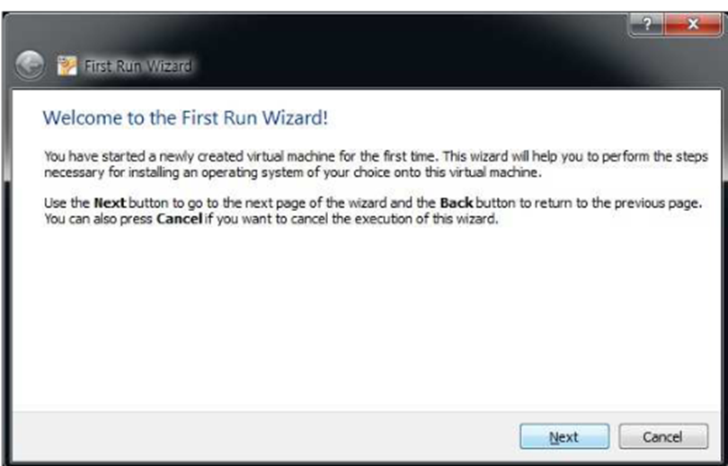

3. Click the folder icon and choose the ubuntu iso file you downloaded and click continue and start

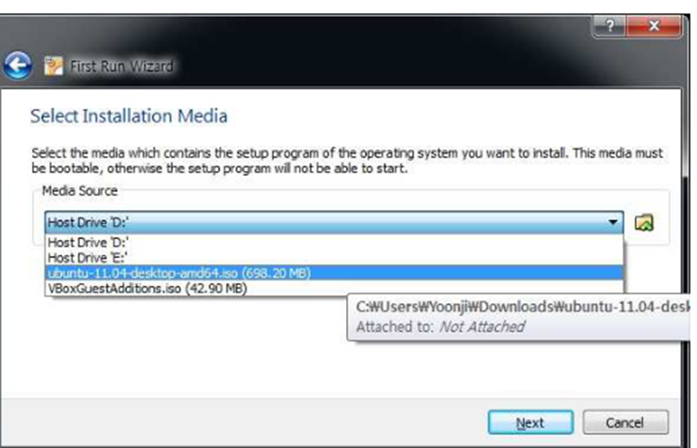

4. Click Install Ubuntu

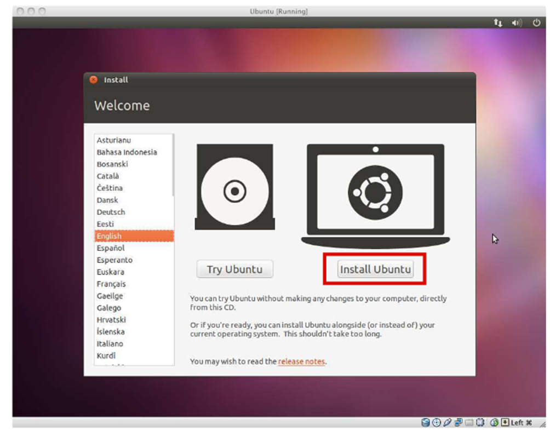

5. Check “Download updates” and click Forward

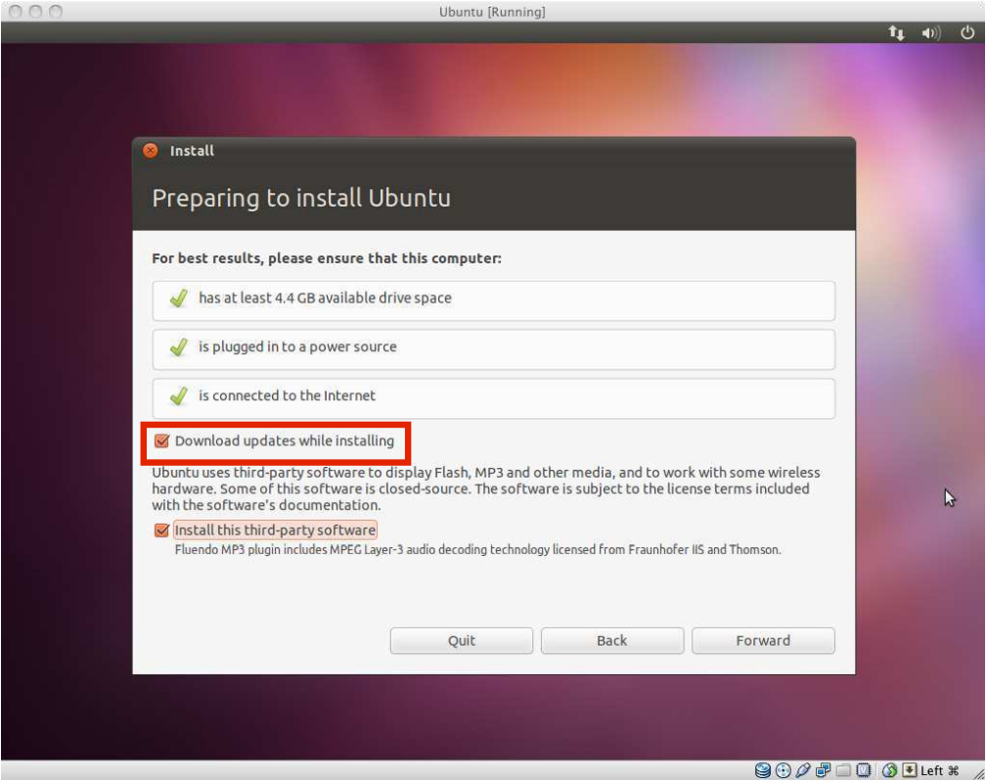

6. Choose “Erase disk and install Ubuntu” and click Forward (Don’t worry, it won’t wipe your computer)

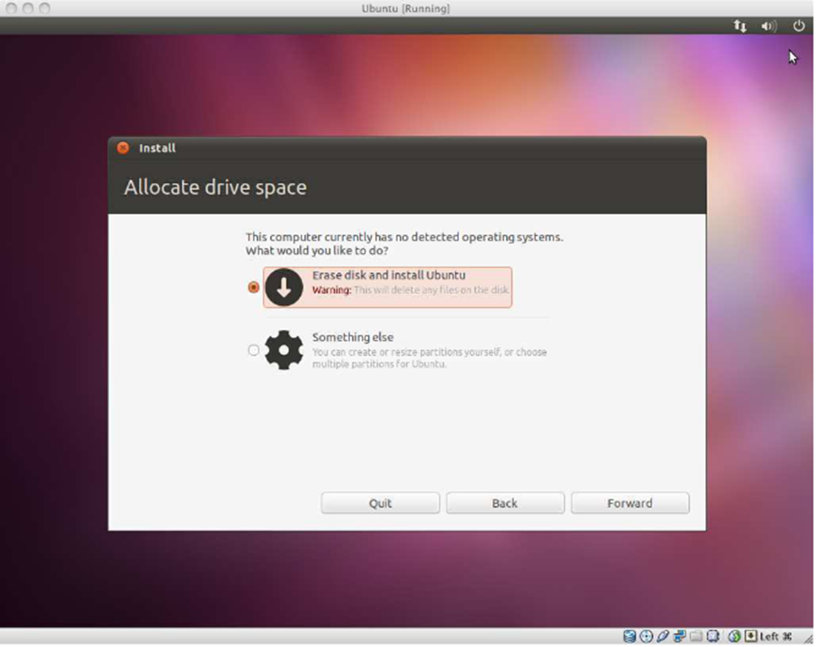

7. Click “Install Now” and wait. Maybe grab a snack.

8. When finished, click Restart and press Enter.

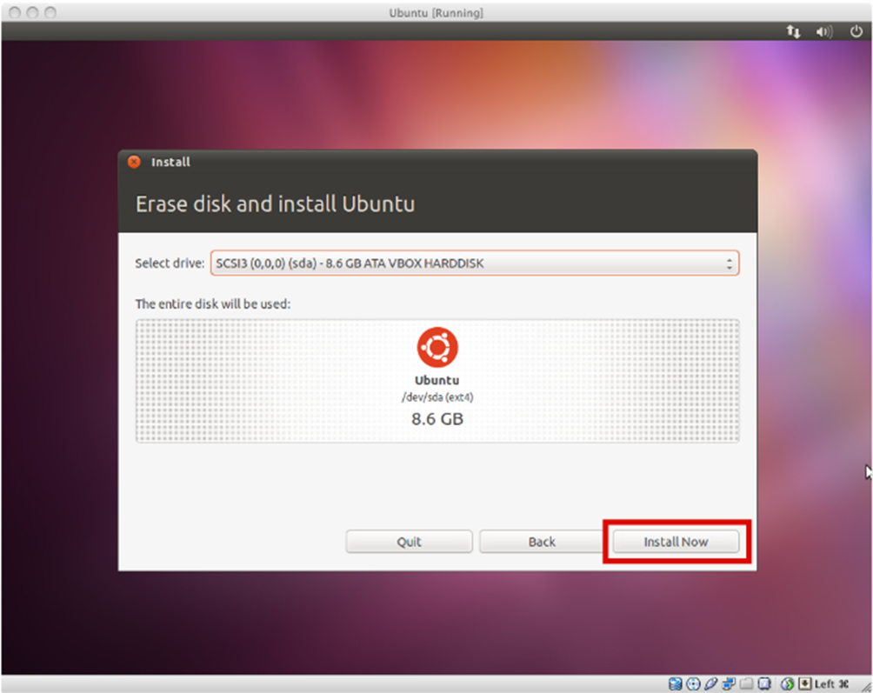

**RESULT**

This is how we can install VirtualBox/VMware Workstation with different flavours of Linux or Windows OS on top of windows 7 or 8 or 10.

**EXPERIMENT-3**

**OBJECTIVE**

Install a C compiler in the virtual machine created using virtual box and execute Simple Programs.

**REQUIREMENTS**

VirtualBox, Ubuntu

**THEORY**

The GNU Compiler Collection (GCC) is an optimizing compiler produced by the GNU Project supporting various programming languages, hardware architectures and operating systems. The Free Software Foundation (FSF) distributes GCC as free software under the GNU General Public License (GNU GPL)

**Procedure**

**Steps to Install GCC Compiler**

1. In ubuntu GCC Compiler is pre-installed which compile c language

2. Open Terminal (Applications -> Accessories -> Terminal)

3. Enter command gcc –version to check which version of GCC is installed and if not installed then it will also tell the command to install it.

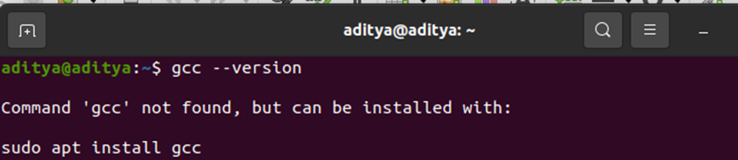

4. To install GCC Compiler enter command sudo apt install gcc

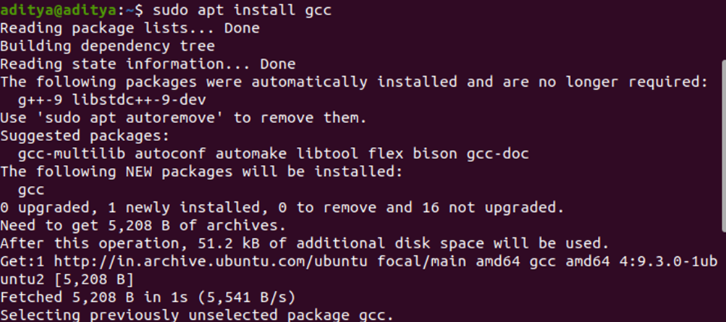

5. To continue type Y and press enter

6. To check whether GCC Compiler is now installed or not enter command

gcc –version

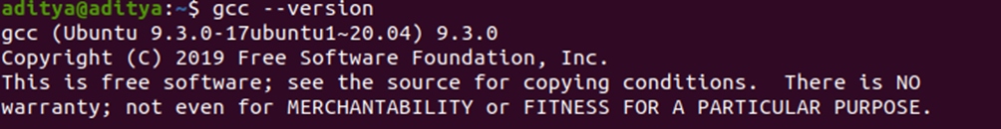

**Steps to Run C Program in GCC Compiler**

1. Open Terminal -> Enter command nano file_name.c -> Press Enter

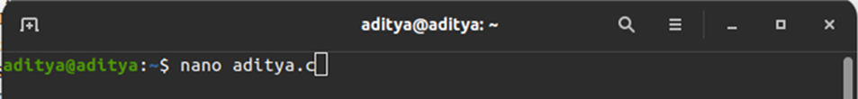

2. Now a file is created in which you can enter your code

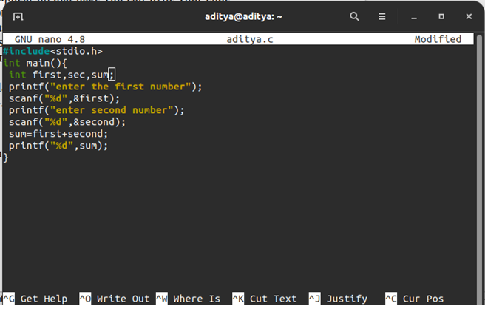

3. After Completion of the code press ctrl + O

4. To save the changes enter Y

5. To close the window press ctrl + X

6. Open Terminal -> Enter gcc file_name.c -o outputfile -> Press Enter

7. Enter command ./outputfile to get the Output of your program

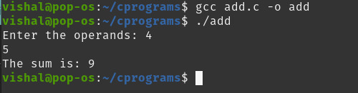

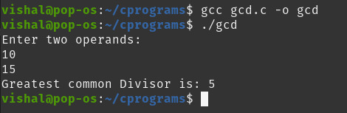

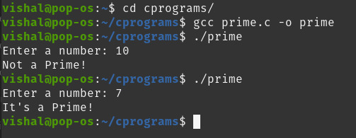

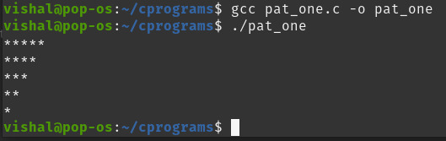

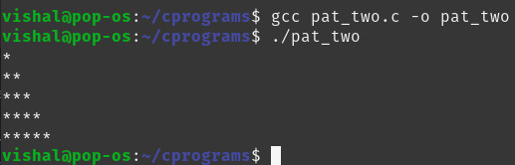

**RESULT**

This is how we can install a C compiler in the virtual machine created using virtual box and execute Simple Programs.

**Experiment – 4**

**Objective**

Install Google Cloud SDK in your Virtual Box in any flavour of Linux

**Requirements**

VirtualBox, Linux ISO File (Ubuntu)

**Theory**

Cloud SDK is a set of tools that you can use to manage resources and applications hosted on Google Cloud. These tools include the gcloud, gsutil, and bq command-line tools. Cloud SDK comes with installable language-specific Cloud Client Libraries and Google API Client Libraries. These libraries use each supported language’s natural conventions and styles, handling authentication, reducing the amount of necessary boilerplate code, and optimizing the developer workflow.

The gcloud CLI manages authentication, local configuration, developer workflow, interactions with Google Cloud APIs. With the gcloud command-line tool, it’s easy to perform many common cloud tasks, like creating a Compute Engine VM instance, managing a Google Kubernetes Engine cluster, and deploying an App Engine application, either from the command line or in scripts and other automations. The gcloud CLI is a part of the Google Cloud SDK. You must download and install the SDK on your system and initialize it before you can use the gcloud command-line tool.

By default, the SDK installs those gcloud CLI commands that are at the General Availability level only.

**Procedure :->**

**Steps to Install Google Cloud SDK CLI ->**

1. First go the link <https://cloud.google.com/sdk/docs/install>

2. Then choose your operating system which is installed in your computer

3. To download the Linux 64-bit archive file from your Terminal, run:

curl -O <https://dl.google.com/dl/cloudsdk/channels/rapid/downloads/google-cloud-sdk-341.0.0-linux-x86_64.tar.gz>

For the 32-bit archive file, run:

curl -O <https://dl.google.com/dl/cloudsdk/channels/rapid/downloads/google- cloud-sdk-341.0.0-linux-x86.tar.gz>

4. Extract the contents of the file to any location on your file system (preferably your Home Directory). If you would like to replace an existing installation, remove the existing google-cloud-sdk directory and extract the archive to the same location.

5. Run the script (from the root of the folder you extracted in the last step) using this command:

./google-cloud-sdk/install.sh

Open a new Terminal so that the changes take place

6. Run gcloud init to initialize the SDK:

./google-cloud-sdk/bin/gcloud init

If you are in a remote terminal session, you can use the --console-only flag to prevent the command from launching a browser-based authorization flow, if required:

./google-cloud-sdk/bin/gcloud init --console-only

**Steps to Make a Project in Google Cloud SDK ->**

1. Create or select a configuration if prompted

If you are initializing a new Cloud SDK installation, gcloud init creates a new one named default for you and sets it as the active configuration. If you have existing configurations, gcloud init prompts you to choose between three options — re-initialize the active one, switch to another one and re-initialize it, or create a new one.

2. Complete the authorization step when prompted

Depending on whether you have previously authorized access to Google Cloud, you may be prompted to log in and grant access in a web browser, or to select an existing account. If you used the –console-only flag and login is required, you must then cut and paste the provided authorization URL into another browser window and follow the prompts provided. When this step is completed, gcloud init sets the account property in the configuration to the specified account.

3. Choose a current Google Cloud project if prompted

If you only have access to one project, including the default project for your user account, gcloud init selects it for you. Otherwise, you can select a project from a list of projects for which you have Owner, Editor or Viewer permissions. gcloud init sets the project property in the configuration to the property you choose. If you have access to more than 200 projects, you will be prompted to enter a project id, create a new project, or list projects.

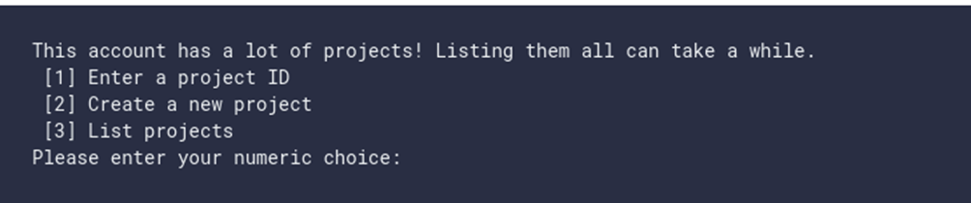

**Result :->**

This is how we can install Google Cloud SDK in Virtual Box in any flavour of Linux

**Ex No. : 5 Date : 07/04/21**

**Experiment – 5**

**Objective :->**

Create a Hello World File on Commercial Cloud Technology: Google Cloud Platform

**Requirements :->**

A Laptop with any OS

**Theory :->**

Google Cloud Platform (GCP) is a suite of cloud computing services provided by Google. It is a public cloud computing platform consisting of a variety of services like compute, storage, networking, application development, Big Data, and more, which run on the same cloud infrastructure that Google uses internally for its end-user products, such as Google Search, Photos, Gmail and YouTube, etc.

The services of GCP can be accessed by software developers, cloud administrators and IT professionals over the Internet or through a dedicated network connection.

The following are some key features of Google Cloud Platform:

* On-demand services: Automated environment with web-based tools. Therefore, no human intervention is required to access the resources.
* Broad network access: The resources and the information can be accessed from anywhere.
* Resource pooling: On-demand availability of a shared pool of computing resources to the users.
* Rapid elasticity: The availability of more resources whenever required. Measured service: Easy-to-pay feature enables users to pay only for consumed services.

Google provides a considerable number of services with several unique features. That is the reason why Google Cloud Platform is continually expanding across the globe. Some of the significant services of GCP are:

* Compute Services
* Networking
* Storage Services
* Big Data
* Security and Identity Management
* Management Tools
* Cloud AI
* IoT (Internet of Things)

**Procedure :->**

1. Open browser (Firefox) and type google cloud platform and press enter to search.

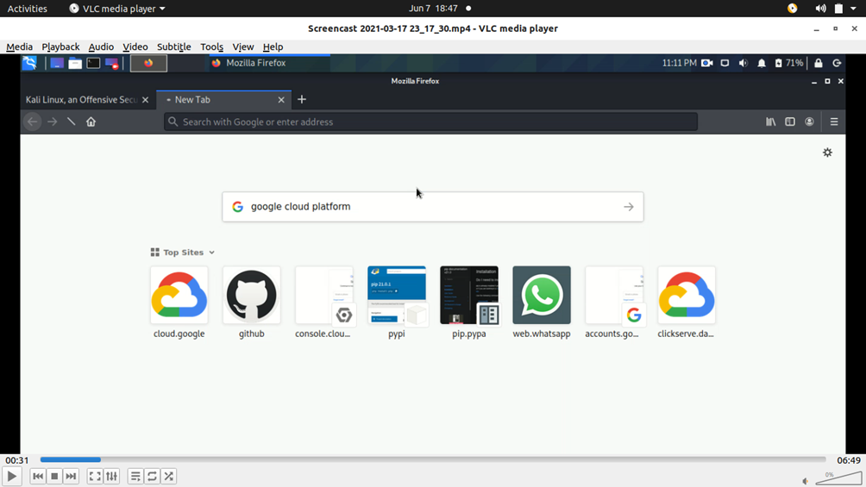

2. Now after results come then go this site (which is shown below) and click on cloud console.

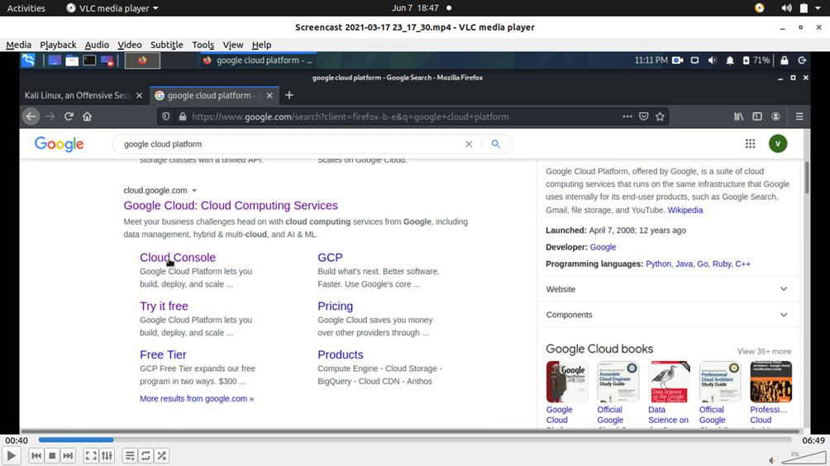

3. Now click on the icon just shown in image a terminal will appear showing your project and your account to which you are sign in.

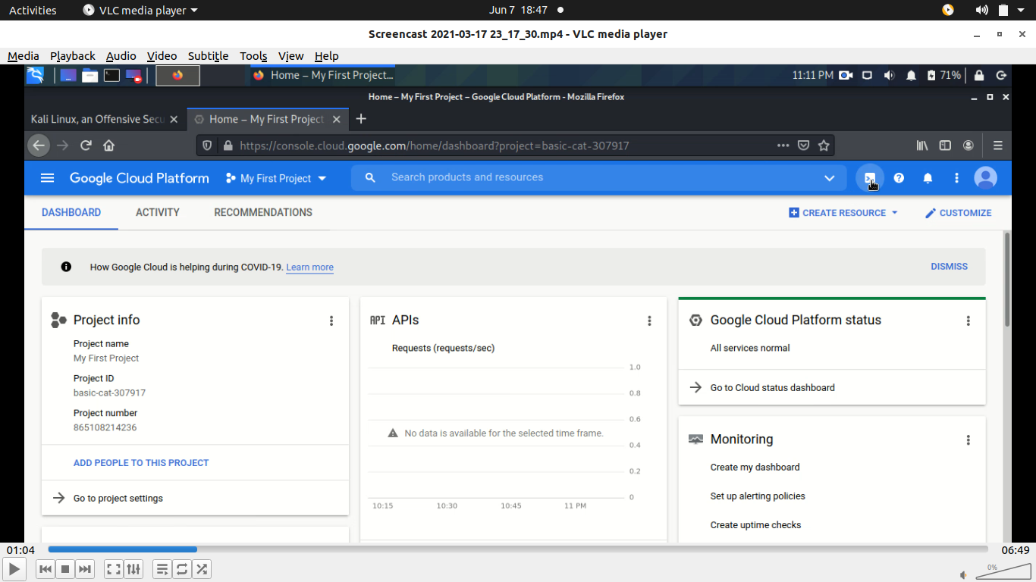

4. Now to create file in your project type nano file_name.c and press enter it will make you to reach a editor where you can write your code.

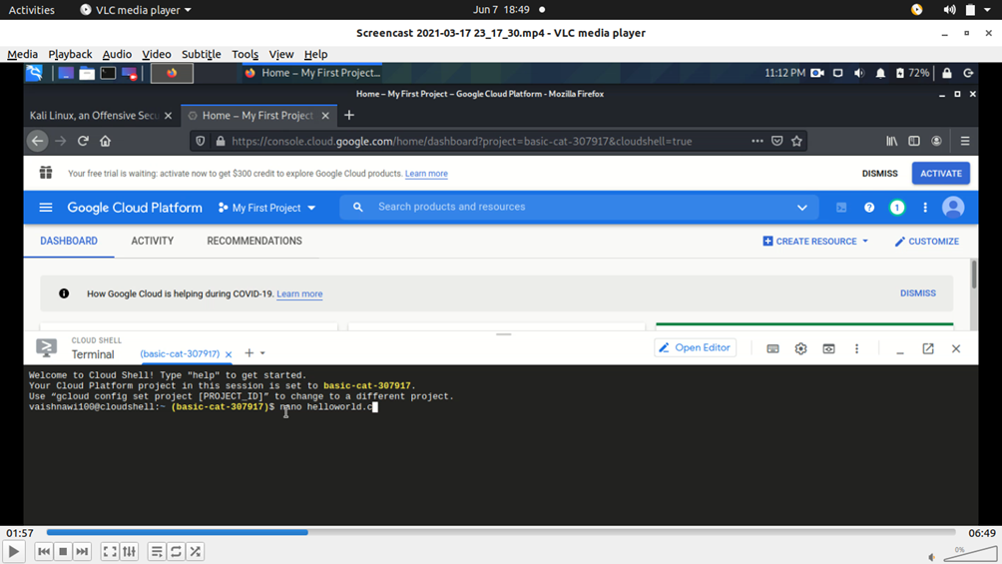

5. Now after typing you code now save it and to do that press ctrl + O and then it will ask to do save that file press Y and press ctrl + X to exit.

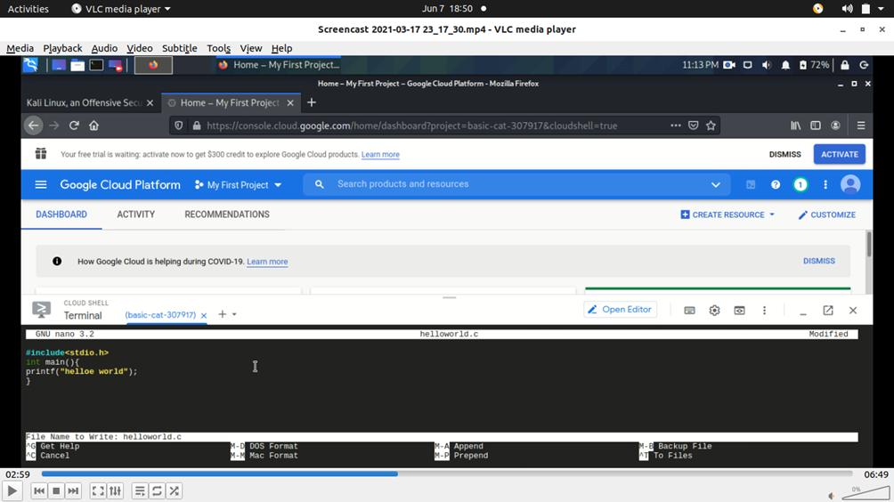

6. Now to check our output of our c file type gcc file_name.c -o anotherfile and press enter this will compile your program and also create an exe file .Now to see output type ./anotherfile and press enter output will be shown on the screen.

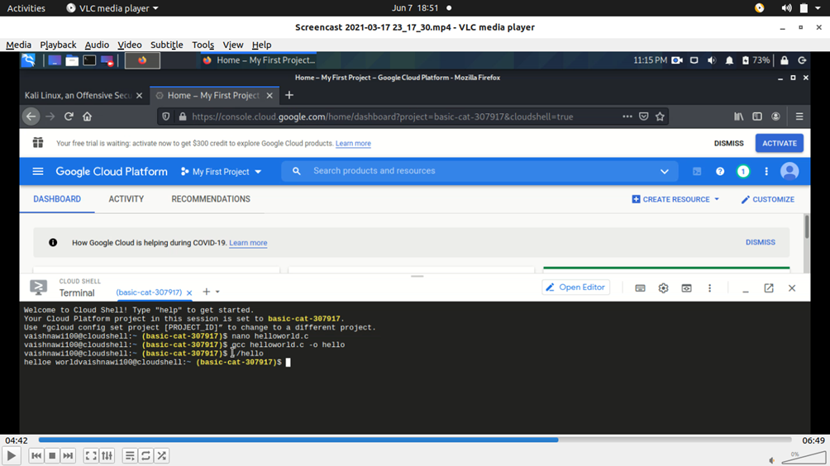

7. Even if anyone want to do these steps graphically then go to open editor and click it.

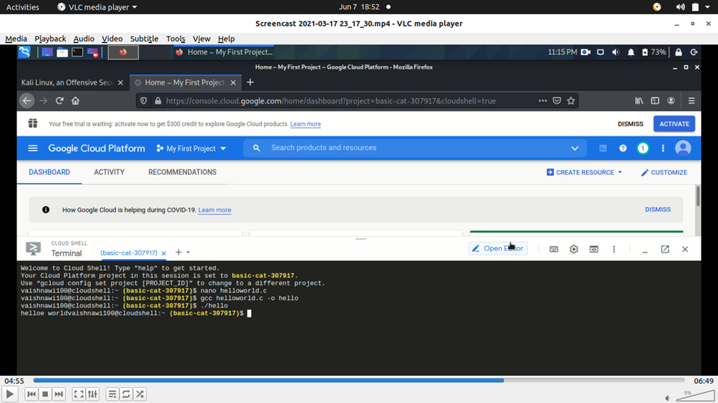

8. A file appear just as we get in Terminal, we can also make files by going to file and click on create and save the file with .c extension and then easily type the code and run it.

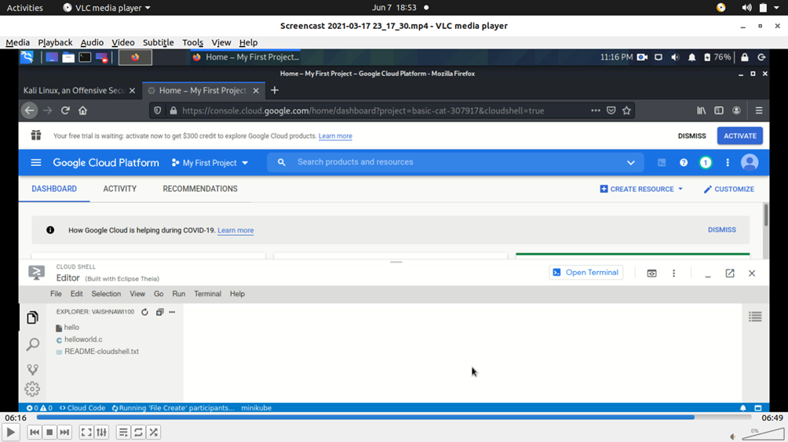

**Result :->**

This is how we can create a hello world file on Commercial Cloud Technology: Google Cloud Platform

**Ex No. : 6 Date : 17/04/21**

**Experiment – 6**

**Objective :->**

Install Google App Engine. Create Hello World App and other simple Web Applications using Python/Java.

**Requirements :->**

Google App Engine, Microsoft Windows

**Theory :->**

Google App Engine (often referred to as GAE or simply App Engine) is a cloud computing platform as a service for developing and hosting web applications in Google-managed data centers. Applications are sandboxed and run across multiple servers. App Engine offers automatic scaling for web applications—as the number of requests increases for an application, App Engine automatically allocates more resources for the web application to handle the additional demand.

The App Engine SDK allows you to run Google App Engine Applications on your local computer. It simulates the run-‐time environment of the Google App Engine infrastructure.

Pre-Requisites: Python 3.9.5

If you don't already have Python 3.9.5 installed in your computer, download and Install Python 3.9.5 from:

<https://www.python.org/ftp/python/3.9.5/python-3.9.5-amd64.exe>

**Procedure :->**

**Steps to Download and Install ->**

1. You can download the Google App Engine SDK by going to:

http://code.google.com/appengine/downloads.html

and download the appropriate install package.

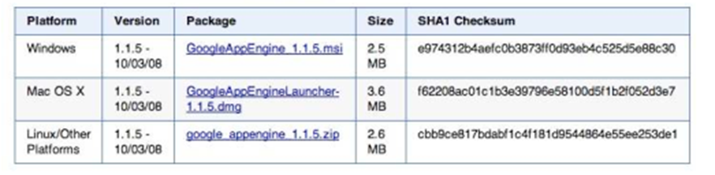

2. Download the Windows installer – the simplest the is to download it to your Desktop or another folder that you remember.

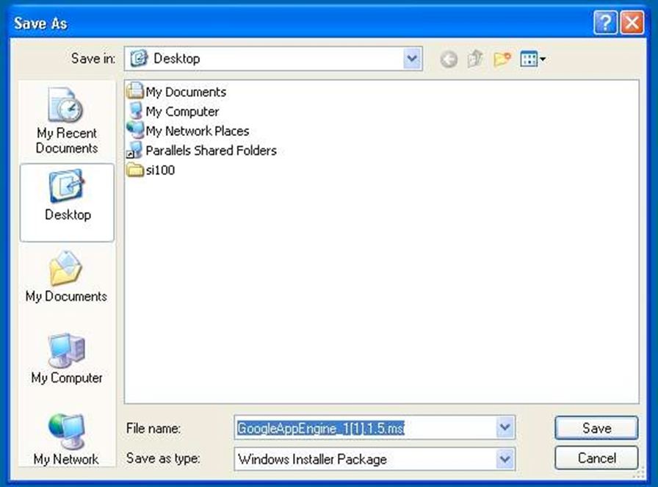

3. Double Click on the Google Application Engine installer.

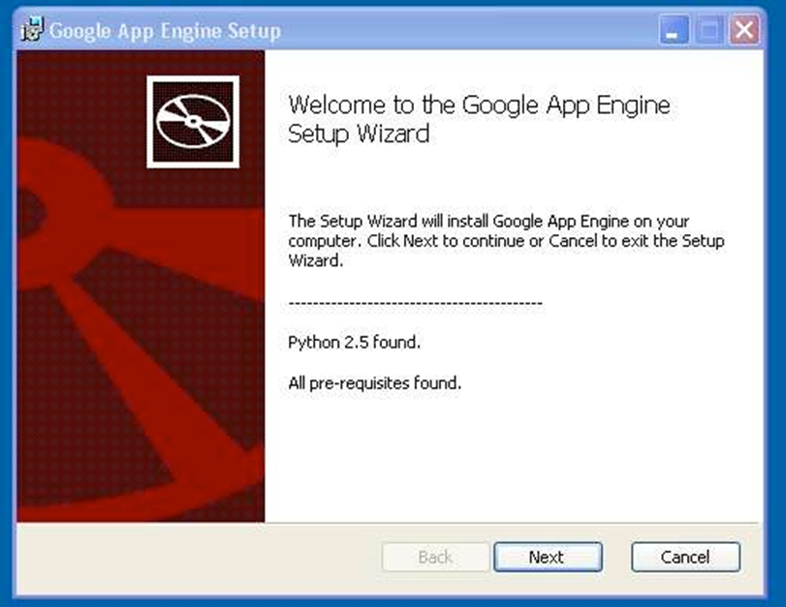

Click through the installation wizard, and it should install the App Engine, if you do not have Python 3.9, it will install Python 3.9 as well.

Once the install is complete you can discard the downloaded installer

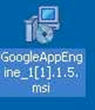

**Steps to Make the Application :->**

1. Now you need to create a simple application. We could use the “+” option to have the launcher make us an application - but instead we will do it by hand to get a better sense of what is going on.

2. Make a folder for your google App Engine applications. Make the folder on my desktop called “apps” -the path to this folder is:

C:\Documents and Settings\csev\Desktop\apps

3. And then make a sub-folder in within apps called “ae-01-trivial”-path to this folder would be:

C:\Documents and Settings\csev\Desktop\apps\ae-01-trivial

4. Using a text-editor create a file called app.yaml in the ae-01-trivial folder with the following contents:

application: ae-01-trivial

version: 1

runtime: python

api_version: 1

handlers:

- url : /.*

script : index.py

Note: Please do not copy and paste these lines into your text editor – you might end up with strange characters – simply type them into your editor.

5. Then create a file in the ae-01-trivial folder called index.py with three lines in it:

print('Content-Type: text/plain')

print(' ')

print('Hello their Chuck')

Note: Similarly, you can create different web applications

**Result :->**

This is how we can install Google App Engine and create Hello World App and other simple Web Applications using Python/Java.

**Ex No. : 7 Date : 17/04/21**

**Experiment – 7**

**Objective :->**

Use Google Application Engine (GAE) Launcher to launch Web Applications

**Requirements :->**

Google App Engine, Microsoft Windows

**Theory :->**

Google App Engine (often referred to as GAE or simply App Engine) is a cloud computing platform as a service for developing and hosting web applications in Google-managed data centers. Applications are sandboxed and run across multiple servers. App Engine offers automatic scaling for web applications—as the number of requests increases for an application, App Engine automatically allocates more resources for the web application to handle the additional demand.

The App Engine SDK allows you to run Google App Engine Applications on your local computer. It simulates the run-‐time environment of the Google App Engine infrastructure.

Pre-Requisite: A Web Application which is need to be launched (Here in this experiment, we will use app.yaml and index.py)

**Procedure :->**

1. To start the Google App Engine Launcher program that can be found under applications. Use the file->Add Existing Application command and navigate into the apps directory and select the ae-01-trivial folder. Once you have added the application, select it so that you can control the application using the launcher.

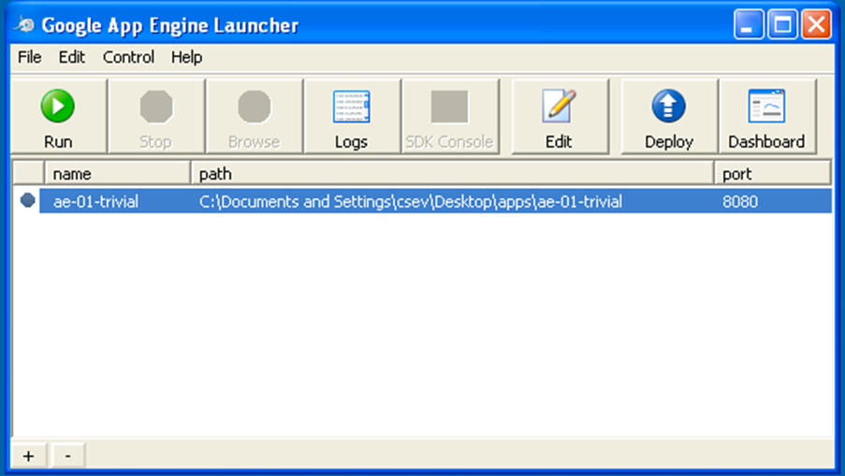

2. Once you have selected your application and press Run. After a few moments your application will start and the launcher will show a little green icon next to your application. Then press Browse to open a browser pointing at your application which is running at <http://localhost:8080/>

Paste http://localhost:8080 into your browser and you should see your application as follows:

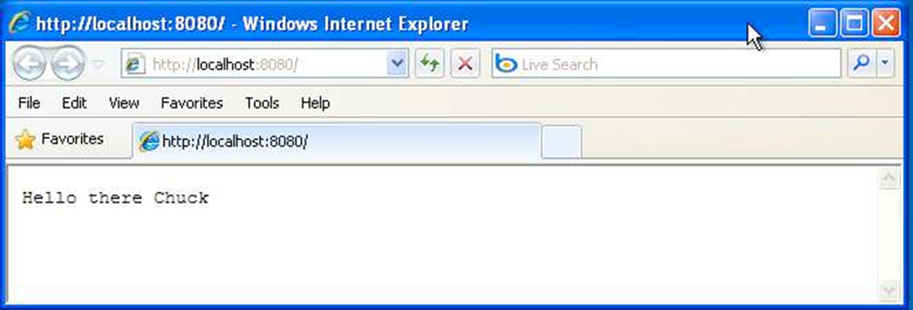

**Watching the Log ->**

You can watch the internal log of the actions that the web server is performing when you are interacting with your application in the browser. Select your application in the launcher and press the Logs button to bring up a log window:

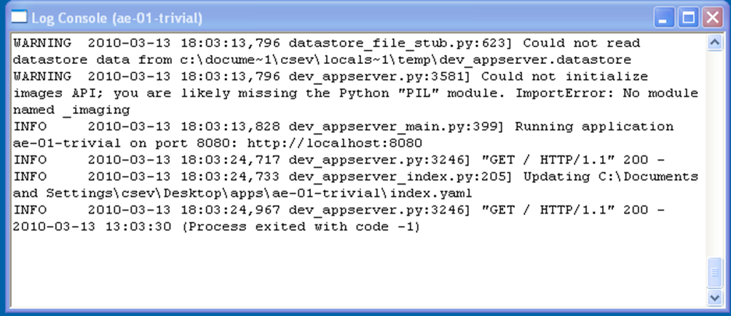

Each time you press Refresh in your browser- you can see it retrieving the output with a GET request.

**Dealing with Errors** **->**

With two files to edit, there are two general categories of errors that you may encounter. If you make a mistake on the app.yaml file, the App Engine will not start and your launcher will show a yellow icon near your application:

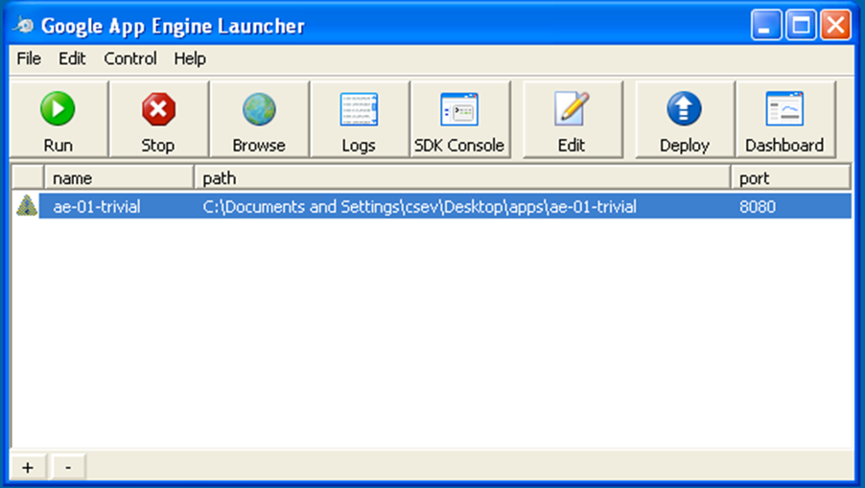

To get more detail on what is going wrong, take a look at the log for the application:

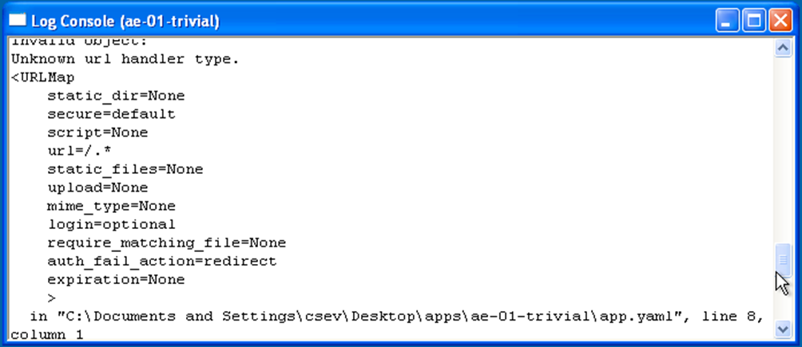

In this instance – the mistake is mis-‐indenting the last line in the app.yaml (line 8).

If you make a syntax error in the index.py file, a Python trace back error will appear in your browser.

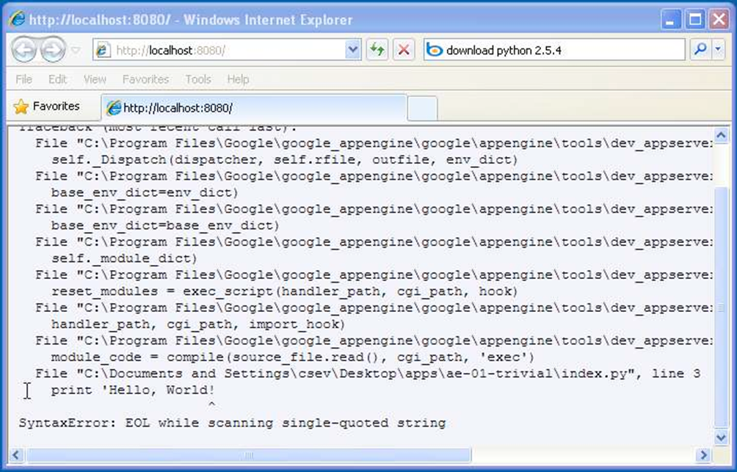

The error you need to see is likely to be the last few lines of the output – in this case there is error in python syntax on line one of our one-line application.

When you make a mistake in the app.yaml file – you must the fix the mistake and attempt to start the application again.

If you make a mistake in a file like index.py, you can simply fix the file and press refresh in your browser – there is no need to restart the server.

**Shutting Down the Server**

To shut down the server, use the Launcher, select your application and press the Stop button.

**Result :->**

This is how we can use Google Application Engine (GAE) Launcher to launch Web Applications.

**Ex No. : 8 Date : 17/04/21**

**Experiment – 8**

**Objective :->**

Implement IaaS using your resources. Technology: OpenStack

**Requirements :->**

OpenStack and any OS

**Theory :->**

**Infrastructure as a Service :**

IaaS includes the delivery of computing infrastructure such as a virtual machine, disk image library, raw block storage, object storage, firewalls, load balancers, IP addresses, virtual local area networks and other features on-demand from a large pool of resources installed in data centres. Cloud providers bill for the IaaS services on a utility computing basis; the cost is based on the amount of resources allocated and consumed.

**OpenStack :**

OpenStack is a free and open source, cloud computing software platform that is widely used in the deployment of infrastructure-as-a-Service (IaaS) solutions. The core technology with OpenStack comprises a set of interrelated projects that control the overall layers of processing, storage and networking resources through a data centre that is managed by the users using a Web-based dashboard, command-line tools, or by using the RESTful API.

Currently, OpenStack is maintained by the OpenStack Foundation, which is a non-profit corporate organisation established in September 2012 to promote OpenStack software as well as its community. Many corporate giants have joined the project, including GoDaddy, Hewlett Packard, IBM, Intel, Mellanox, Mirantis, NEC, NetApp, Nexenta, Oracle, Red Hat, SUSE Linux, VMware, Arista Networks, AT&T, AMD, Avaya, Canonical, Cisco, Dell, EMC, Ericsson, Yahoo!, etc**.**

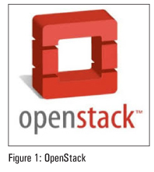

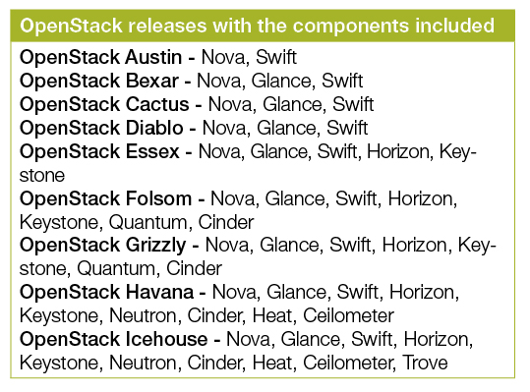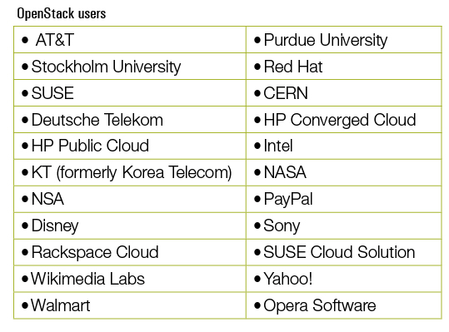

**OpenStack computing components :**

OpenStack has a modular architecture that controls large pools of compute, storage and networking resources ->

**Compute (Nova):** OpenStack Compute (Nova) is the fabric controller, a major component of Infrastructure as a Service (IaaS), and has been developed to manage and automate pools of computer resources. It works in association with a range of virtualisation technologies. It is written in Python and uses many external libraries such as Eventlet, Kombu and SQLAlchemy.

**Object storage (Swift):** It is a scalable redundant storage system, using which objects and files are placed on multiple disks throughout servers in the data centre, with the OpenStack software responsible for ensuring data replication and integrity across the cluster. OpenStack Swift replicates the content from other active nodes to new locations in the cluster in case of server or disk failure.

**Block storage (Cinder):** OpenStack block storage (Cinder) is used to incorporate continual block-level storage devices for usage with OpenStack compute instances. The block storage system of OpenStack is used to manage the creation, mounting and unmounting of the block devices to servers. Block storage is integrated for performance-aware scenarios including database storage, expandable file systems or providing a server with access to raw block level storage. Snapshot management in OpenStack provides the authoritative functions and modules for the back-up of data on block storage volumes. The snapshots can be restored and used again to create a new block storage volume.

**Networking (Neutron):** Formerly known as Quantum, Neutron is a specialised component of OpenStack for managing networks as well as network IP addresses. OpenStack networking makes sure that the network does not face bottlenecks or any complexity issues in cloud deployment. It provides the users continuous self-service capabilities in the network’s infrastructure. The floating IP addresses allow traffic to be dynamically routed again to any resources in the IT infrastructure, and therefore the users can redirect traffic during maintenance or in case of any failure. Cloud users can create their own networks and control traffic along with the connection of servers and devices to one or more networks. With this component, OpenStack delivers the extension framework that can be implemented for managing additional network services including intrusion detection systems (IDS), load balancing, firewalls, virtual private networks (VPN) and many others.

**Dashboard (Horizon):** The OpenStack dashboard (Horizon) provides the GUI (Graphical User Interface) for the access, provision and automation of cloud-based resources. It embeds various third-party products and services including advance monitoring, billing and various management tools.

**Identity services (Keystone):** Keystone provides a central directory of the users, which is mapped to the OpenStack services they are allowed to access. It refers and acts as the centralised authentication system across the cloud operating system and can be integrated with directory services like LDAP. Keystone supports various authentication types including classical username and password credentials, token-based systems and other log-in management systems.

**Image services (Glance):** OpenStack Image Service (Glance) integrates the registration, discovery and delivery services for disk and server images. These stored images can be used as templates. It can also be used to store and catalogue an unlimited number of backups. Glance can store disk and server images in different types and varieties of back-ends, including Object Storage.

**Deployment of OpenStack using DevStack :**

DevStack is used to quickly create an OpenStack development environment. It is also used to demonstrate the starting and running of OpenStack services, and provide examples of using them from the command line. DevStack has evolved to support a large number of configuration options and alternative platforms and support services. It can be considered as the set of scripts which install all the essential OpenStack services in the computer without any additional software or configuration. To implement DevStack, first download all the essential packages, pull in the OpenStack code from various OpenStack projects, and set everything for the deployment.

**Procedure :->**

To install OpenStack using DevStack, any Linux-based distribution with 2GB RAM can be used to start the implementation of IaaS.

Here are the steps that need to be followed for the installation ->

1. Install Git



2. Clone the DevStack repository and change the directory. The code will set up the cloud infrastructure.

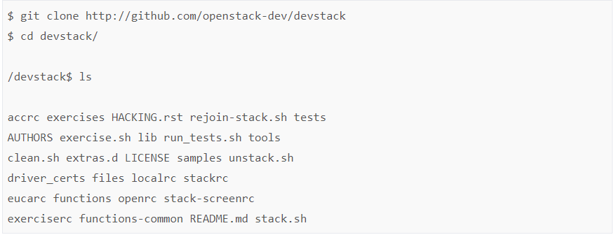

stack.sh, unstack.sh and rejoin-stack.sh are the most important files. stack.sh script is used to set up DevStack.unstack.sh is used to destroy the DevStack setup.

If you are on the earlier execution of ./stack.sh, the environment can be brought up by executing the rejoin_stack.sh script.

3. Execute the stack.sh script:



4. Here, the MySQL database password is entered. There is no need to worry about the installation of MySQL separately on this system. We have to specify a password and this script will install MySQL, and use this password there.

Finally, we will have the script ending as follows:

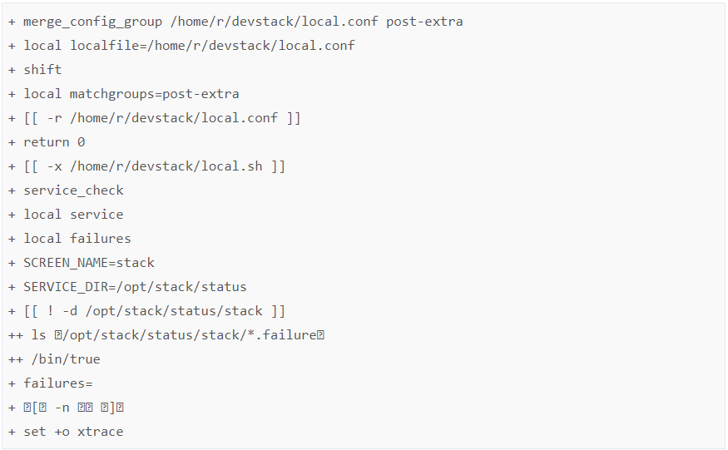

* Horizon is now available at http://1.1.1.1/
* Keystone is serving at http://1.1.1.1:5000/v2.0/
* Examples on using the novaclient command line are in exercise.sh
* The default users are: admin and demo
* The password: nova
* This is your host IP: 1.1.1.1

After all these steps, the machine becomes the cloud service providing platform. Here, 1.1.1.1 is the IP of my first network interface.

We can view all the process logs inside the screen, by typing the following command:



Executing the following will kill all the services, but it should be noted that it will not delete any of the code.

To bring down all the services manually, type:



**Result :->**

This is how we can implement IaaS using our resources and using technology OpenStack

**Ex No. : 9 Date : 24/04/21**

**Experiment – 9**

**Objective :->**

Virtualization: understand different types of Virtualization and Hypervisors.

**Requirements :->**

Any Text Editor

**Theory :->**

**Virtualization:**

Virtualization is a technique of how to separate a service from the underlying physical delivery of that service. It is the process of creating a virtual version of something like computer hardware. It was initially developed during the mainframe era. It involves using specialized software to create a virtual or software-created version of a computing resource rather than the actual version of the same resource. With the help of Virtualization, multiple operating systems and applications can run on same machine and its same hardware at the same time, increasing the utilization and flexibility of hardware.

In other words, one of the main cost effective, hardware reducing, and energy saving techniques used by cloud providers is virtualization. Virtualization allows to share a single physical instance of a resource or an application among multiple customers and organizations at one time. It does this by assigning a logical name to a physical storage and providing a pointer to that physical resource on demand.

The term virtualization is often synonymous with hardware virtualization, which plays a fundamental role in efficiently delivering Infrastructure-as-a-Service (IaaS) solutions for cloud computing. Moreover, virtualization technologies provide a virtual environment for not only executing applications but also for storage, memory, and networking.

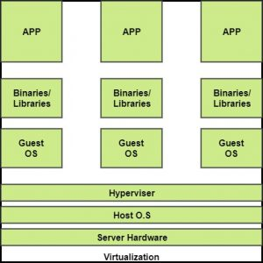

The machine on which the virtual machine is going to be build is known as Host Machine and that virtual machine is referred as a Guest Machine.

**Benefits of Virtualization ->**

1. More flexible and efficient allocation of resources.

2. Enhance development productivity.

3. It lowers the cost of IT infrastructure.

4. Remote access and rapid scalability.

5. High availability and disaster recovery.

6. Pay peruse of the IT infrastructure on demand.

7. Enables running multiple operating systems.

**Types of Virtualizations ->**

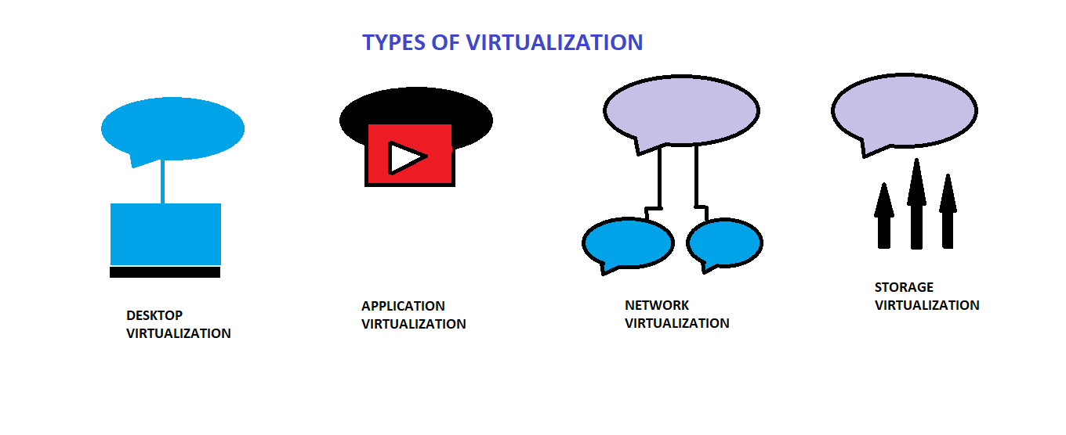

**1. Application Virtualization:**

Application virtualization helps a user to have remote access of an application from a server. The server stores all personal information and other characteristics of the application but can still run on a local workstation through the internet. Example of this would be a user who needs to run two different versions of the same software. Technologies that use application virtualization are hosted applications and packaged applications.

**2. Network Virtualization:**

The ability to run multiple virtual networks with each has a separate control and data plan. It co-exists together on top of one physical network. It can be managed by individual parties that potentially confidential to each other.

Network virtualization provides a facility to create and provision virtual networks—logical switches, routers, firewalls, load balancer, Virtual Private Network (VPN), and workload security within days or even in weeks.

**3. Desktop Virtualization:**

Desktop virtualization allows the users’ OS to be remotely stored on a server in the data centre. It allows the user to access their desktop virtually, from any location by a different machine. Users who want specific operating systems other than Windows Server will need to have a virtual desktop. Main benefits of desktop virtualization are user mobility, portability, easy management of software installation, updates and patches.

**4. Storage Virtualization:**

Storage virtualization is an array of servers that are managed by a virtual storage system. The servers aren’t aware of exactly where their data is stored, and instead function more like worker bees in a hive. It makes managing storage from multiple sources to be managed and utilized as a single repository. storage virtualization software maintains smooth operations, consistent performance and a continuous suite of advanced functions despite changes, break down and differences in the underlying equipment.

**5. Server Virtualization:**

This is a kind of virtualization in which masking of server resources takes place. Here, the central-server (physical server) is divided into multiple different virtual servers by changing the identity number, processors. So, each system can operate its own operating systems in isolate manner. Where each sub-sever knows the identity of the central server. It causes an increase in the performance and reduces the operating cost by the deployment of main server resources into a sub-server resource. It’s beneficial in virtual migration, reduce energy consumption, reduce infrastructural cost etc.

**6. Data Virtualization:**

This is the kind of virtualization in which the data is collected from various sources and managed that at a single place without knowing more about the technical information like how data is collected, stored & formatted then arranged that data logically so that its virtual view can be accessed by its interested people and stakeholders, and users through the various cloud services remotely. Many big giant companies are providing their services like Oracle, IBM, At scale, Cdata etc.

It can be used to performing various kind of tasks such as:

* Data-integration
* Business-integration
* Service-oriented architecture data-services
* Searching organizational data

**Hypervisors:**

A hypervisor is a crucial piece of software that makes virtualization possible. It abstracts guest machines and the operating system they run on, from the actual hardware.

Hypervisors create a virtualization layer that separates CPU / Processors, RAM and other physical resources from the virtual machines you create.

The machine we install a hypervisor on is called a host machine, versus guest virtual machines that run on top of them.

Hypervisors emulate available resources so that guest machines can use them. No matter what operating system you boot up with a virtual machine, it will think that actual physical hardware is at its disposal.

From a VM’s standpoint, there is no difference between the physical and virtualized environment. Guest machines do not know that the hypervisor created them in a virtual environment. Or that they are sharing available computing power. VMs run simultaneously with the hardware that powers them, and so they are entirely dependent on its stable operation.

* Type 1 Hypervisor (also called bare metal or native)
* Type 2 Hypervisor (also known as hosted hypervisors)

**Type 1 Hypervisor:**

A bare-metal hypervisor (Type 1) is a layer of software we install directly on top of a physical server and its underlying hardware.

There is no software or any operating system in between, hence the name bare-metal hypervisor. A Type 1 hypervisor is proven in providing excellent performance and stability since it does not run inside Windows or any other operating system.

Type 1 hypervisors are mainly found in enterprise environments.

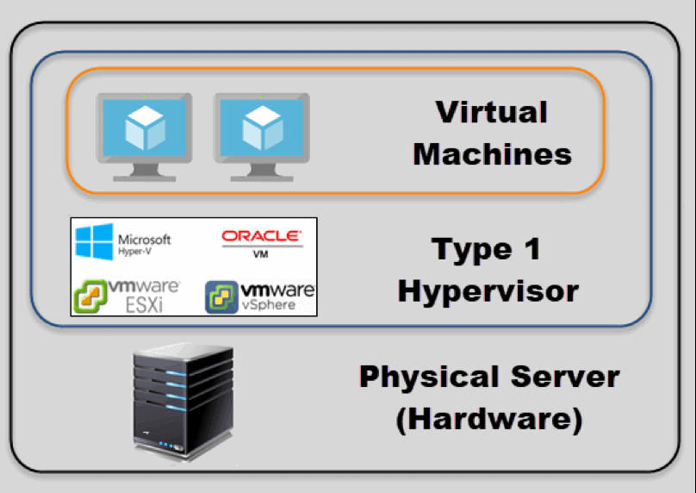

Below is an example of a VMware type 1 hypervisor’s screen after the server boots up.

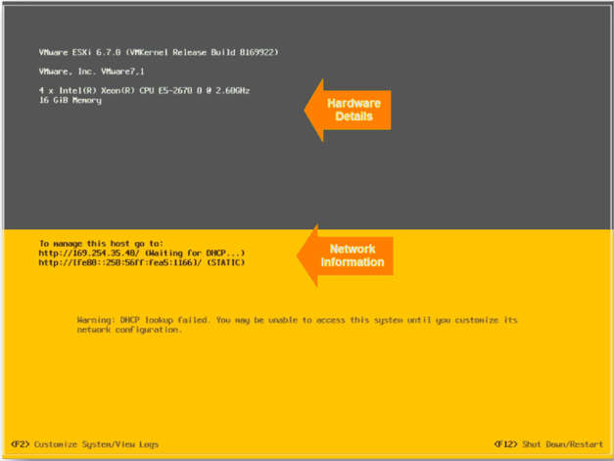

**Type 2 Hypervisor:**

This type of hypervisor runs inside of an operating system of a physical host machine.

This is why we call type 2 hypervisors – **hosted hypervisors**. As opposed to type 1 hypervisors that run directly on the hardware, hosted hypervisors have one software layer underneath. In this case we have:

* A physical machine.
* An operating system installed on the hardware (Windows, Linux, macOS).
* A type 2 hypervisor software within that operating system.
* The actual instances of guest virtual machines.

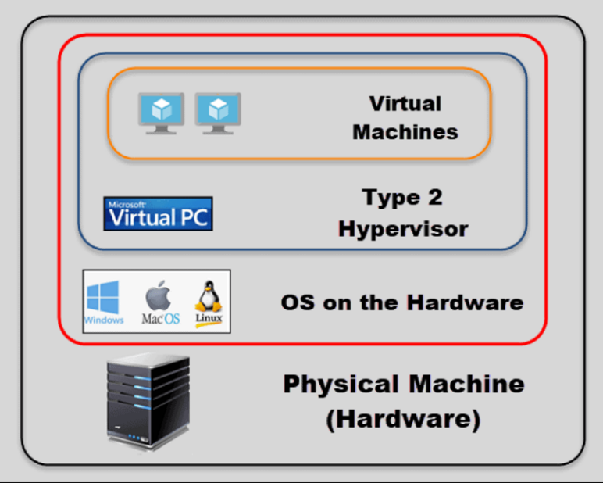

Type 2 hypervisors are typically found in environments with a small number of servers.

What makes them convenient is that you do not need a management console on another machine to set up and manage virtual machines. You can do all of this on the server where you install the hypervisor. They are not any different from the other applications you have in your operating system.

When you launch a virtual machine, you get another window to perform all tasks.

Here is one example of a type 2 hypervisor interface (VirtualBox by Oracle):

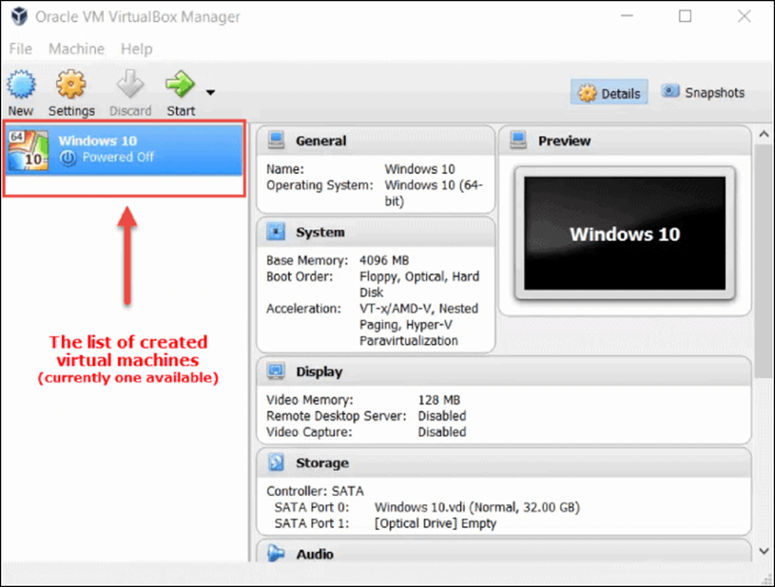

**Result :->**

In this experiment, we have discussed about different types of Virtualization and Hypervisors.

**Ex No. : 10 Date : 24/04/21**

**Experiment – 10**

**Objective :->**

Understanding Cloud Security, Data Dictionary and Web Server Security.

**Requirements :->**

MS Word

**Theory :->**

**Cloud Security:**

Cloud security, also known as cloud computing security, consists of a set of policies, controls, procedures and technologies that work together to protect cloud-based systems, data, and infrastructure. These security measures are configured to protect cloud data, support regulatory compliance and protect customers' privacy as well as setting authentication rules for individual users and devices. From authenticating access to filtering traffic, cloud security can be configured to the exact needs of the business. And because these rules can be configured and managed in one place, administration overheads are reduced and IT teams empowered to focus on other areas of the business.

Some practices regarding Cloud Security are ->

* **Strategy & Policy**: A holistic cloud security program should account for ownership and accountability (internal/external) of cloud security risks, gaps in protection/compliance, and identify controls needed to mature security and reach the desired end state.
* **Network Segmentation**: In multi-tenant environments, assess what segmentation is in place between your resources and those of other customers, as well as between your own instances. Leverage a zone approach to isolate instances, containers, applications, and full systems from each other when possible.
* **Identity and Access Management and Privileged Access Management**: Leverage robust identity management and authentication processes to ensure only authorized users to have access to the cloud environment, applications, and data. Enforce least privilege to restrict privileged access and to harden cloud resources (for instance, only expose resources to the Internet as is necessary, and de-activate unneeded capabilities/features/access). Ensure privileges are role-based, and that privileged access is audited and recorded via session monitoring.
* **Discover and Onboard Cloud Instances and Assets**: Once cloud instances, services, and assets are discovered and grouped, bring them under management (i.e., managing and cycling passwords, etc.). Discovery and onboarding should be automated as much as possible to eliminate shadow IT.
* **Password Control (Privileged and Non-Privileged Passwords)**: Never allow the use of shared passwords. Combine passwords with other authentication systems for sensitive areas. Ensure password management best practices.
* **Vulnerability Management**: Regularly perform vulnerability scans and security audits, and patch known vulnerabilities.
* **Encryption**: Ensure your cloud data is encrypted, at rest, and in transit.
* **Disaster Recovery**: Be aware of the data backup, retention, and recovery policies and processes for your cloud vendor(s). Do they meet your internal standards? Do you have break-glass strategies and solutions in place?
* **Monitoring, Alerting, and Reporting**: Implement continual security and user activity monitoring across all environments and instances. Try to integrate and centralize data from your cloud provider (if available) with data from in-house and other vendor solutions, so you have a holistic picture of what is happening in your environment.

**Data Dictionary:**

Data Dictionary is a collection of names, definitions, and attributes about data elements that are being used or captured in a database, information system, or part of a research project. It describes the meanings and purposes of data elements within the context of a project, and provides guidance on interpretation, accepted meanings and representation. A Data Dictionary also provides metadata about data elements. The metadata included in a Data Dictionary can assist in defining the scope and characteristics of data elements, as well the rules for their usage and application.

The data dictionary in general contains information about the following ->

* Names of all the database tables and their schemas.
* Details about all the tables in the database, such as their owners, their security constraints, when they were created etc.
* Physical information about the tables such as where they are stored and how.
* Table constraints such as primary key attributes, foreign key information etc.
* Information about the database views that are visible.

There are two types of data dictionaries: active and passive. An active data dictionary is tied to a specific database which makes data transference a challenge, but it updates automatically with the data management system. A passive data dictionary isn’t tied to a particular database or server, but it also must be manually maintained to prevent metadata from being out of sync.

The main reason companies use data dictionaries is to document and share data structures and other information for all involved with a project or database. Using a shared dictionary ensures the same quality, meaning, and relevance for all data elements for all team members. The data dictionary will define conventions for the project and consistency throughout the dataset. Without a data dictionary, there’s a higher risk of losing crucial information in translation and transition. Using a data dictionary also helps teams analyse the data easier later on.

**Web Server Security:**

Web Server Security is the protection of information assets that can be accessed from a Web server.

Web servers are one of the most targeted public faces of an organization, because of the sensitive data they usually host. Securing a web server is as important as securing the website or web application itself and the network around it. If you have a secure web application and an insecure web server, or vice versa, it still puts your business at a huge risk. Your company’s security is as strong as its weakest point.

Web server security is important for any organization that has a physical or virtual Web server connected to the Internet. It requires a layered defence and is especially important for organizations with customer-facing websites.

Separate servers should be used for internal and external-facing applications and servers for external-facing applications should be hosted on a DMZ or containerized service network to prevent an attacker from exploiting a vulnerability to gain access to sensitive internal information.

Penetration tests should be run on a regular basis to identify potential attack vectors, which are often caused by out-of-date server modules, configuration or coding errors and poor patch management. Web site security logs should be audited on a continuous basis and stored in a secure location.

Other best practices include using a separate development server for testing and debugging, limiting the number of superuser and administrator accounts and deploying an intrusion detection system (IDS) that includes monitoring and analysis of user and system activities, the recognition of patterns typical of attacks, and the analysis of abnormal activity patterns.

**Result :->**

In this experiment, we have discussed about Cloud Security, Data Dictionary and Web Server Security.

**Ex No. : 11 Date : 24/04/21**

**Experiment – 11**

**Objective :->**

Case Study of Amazon Web Services.

**Requirements :->**

MS Word

**Theory :->**

**Introduction:**

The Amazon Web Services (AWS) is a set (more than 25) of proprietary web-based services owned by Amazon.com. All these services ranging from simple storage to sophisticated database services constitute the cloud platform offered by Amazon. An extensive list of customers for AWS include Dropbox, UniLever, Airbnb, Nasdaq, Netix. As of 2007, there are more than 300K developers actively using AWS. It is one of the pioneers which brought the cloud computing closer to masses helping number of start-ups bootstrap their businesses. AWS is a true testimony of how a just-Internet-enabled business grew into a complete-technology-company competing with dedicated technology companies- the likes of Google, Microsoft, and Apple.

In the following case study, we analyse the various aspects of AWS and the business and economic principles that drove their creation and design.

**History of AWS:**

The Amazon web services was launched in 2002 and the portfolio of services expanded over time. The Amazon Elastic Cloud EC2 was built in 2004, which is central to the whole AWS infrastructure. Amazon itself is one of the clients for the EC2 platform. Amazon Virtual Private Cloud (Amazon VPC) is the latest (2011 August) addition to the list.

In spite of strong guarantees on the availability of the infrastructure to the clients, AWS experienced major outage recently, thus strengthening the critics of cloud computing initiatives.

Today, AWS has a wide set of products including the following most popular ones ->

a. Amazon Elastic Compute Cloud (EC2)

b. Amazon Elastic MapReduce

c. Amazon Mechanical Turk (Mturk)

d. Amazon Relational Database Service (RDS)

e. Amazon Simple Storage Service (S3)

f. Amazon Simple DB

g. Amazon Dynamo DB

The less known ones include ->

1. Amazon AWS Authentication

2. Amazon CloudFront

3. Amazon CloudWatch

4. Amazon Elastic Beanstalk

5. Amazon Elastic Block Store (EBS)

6. Amazon ElastiCache

7. Amazon Flexible Payments Service (FPS)

8. Amazon Fulfilment Web Service

9. Amazon Historical Pricing

10. Amazon Product Advertising API

11. Amazon Route 53

12. Amazon Simple Email Service (SES)

13. Amazon Simple Queue Service (SQS)

14. Amazon Simple Notification Service (SNS)

15. Amazon Simple Workflow (SWF)

16. Amazon Virtual Private Cloud (VPC)

17. AWS CloudFormation

18. AWS Import/Export

19. AWS Management Console (AWS Console)

20. AWS Storage Gateway

**Business Analysis:**

In the following, we analyse the various forces that lead to the creation of AWS and that drive its explosive growth in adaptation of the services. Namely, we discuss

1. the motivation and strategy behind creation of AWS

2. the forces that are driving its growth

3. how the AWS growth in turn acted as a strong catalyst to the success of Amazon's original core business and associated products

**Creation of AWS: Sell what we already have:**

Amazon core business of selling goods (ranging from books to fresh food and electronics to fashion cloths) through its e-commerce portal (Amazon.com) has seen exponential growth in the past decade. A total of 650 million users, per year (as of 2008), visit Amazon.com portal generating a revenue of more than 15 billion USD for Amazon. There are 76 million active customers and 1.3 million sellers depend on the portal. Thanks to the sheer number of the visitors and volume of the transactions they initiate, the scale of the infrastructure needed by Amazon to run its core business is unprecedented.

Hence, after building such a massive storage and computing infrastructure that is always available, resistant to failures, its intuitive to open up the infrastructure and sell it as a commodity.

This helps Amazon not only to expand the infrastructure further thus benefitting its own core business but also to attract more customers to this new product. Thus, Amazon launched Amazon Web Services in 2002 and slowly adding more and more services to the AWS portfolio, making Amazon as the market leader in cloud computing world.

**Growth Factors and Issues:**

**1. Economies of scale leads to cheaper service provision**

The scale of the AWS infrastructure is unmatched. The EC2 platform has more than 17K cores which positions AWS at 42 in top 500- super computers list. Such a scale has huge cost efficiencies through a combination of high-volume, low-cost procurement thanks to bargaining power of buyer Amazon. In addition, constant technological innovations in design, operations and management of the data centers and AWS help Amazon to reduce the prices further. Amazon has lowered prices 19 times since the start of AWS in 2007. Amazon CEO's vision of providing premium services at non-premium prices extends to AWS as well. GigaOm once commented- “When Amazon Web Services isn't adding new services, it's cutting prices on those it already offers. The speed with which Amazon rolls out new services, and commoditizes them with its pricing, is its chief advantage.".

Because of cheaper service provision, there is a flood of new customers for AWS. However, with the advent of new competitors like Google Cloud Engine, there is an ever-increasing stress on Amazon in pricing. However, presence of more than 25 services in its portfolio, AWS is more lucrative for a customer to deploy his business on AWS than a cheaper service provider who offers lesser number of services. For example, consider the case of AWS which provides both computing (EC2) and storage services (S3) and another provider who provides only a storage service but at a cheaper price. Given that any typical large business needs both scalable computing and storage, AWS is most preferred choice which offers a complete basket of services. Especially AWS providing services of Database (RelationalDatabase service, Simple DB, etc.) along with simple storage and computing makes the choice of AWS very attractive for any customer. In addition, Amazon has a better/cheaper pricing if several of services from AWS are used by a single client, for example, AWS allows free unlimited data transfers among different services, thus making it cost effective. This diversified service offering is something AWS is benefited from Amazon's core business which expanded itself from selling only books to almost any consumer good through its portal.

**2. Simultaneous Competition and Coopetition**

AWS positions Amazon in an interesting situation of simultaneous competition and coopetition with some of very big players in technological markets. Most of the AWS services can be seen as repackaging some of competitor's products and re branding them through their AWS portfolio. For example, Amazon Relations Database Service (RDS), which is part of AWS, heavily uses Microsoft's SQL Server and Oracle. Customers of RDS can choose one of these SQL flavours as part of their contract for RDS. Because of the very large client base for the RDS service, Amazon ends up as a big customer for Oracle and Microsoft for their database products. Amazon is in a coopetition with these players to offer a value-added service to the end users. End users, instead of purchasing Oracle or Microsoft's database products, they buy Amazon's RDS service. Thus, Amazon can be understood to be a middle man in the supply chain between end user and the original service providers. Interestingly, Oracle and Microsoft have AWS alternatives namely, Oracle Cloud and Windows Azure. Thus, Amazon has to compete with these players while engaging in a coopetition simultaneously.

**3. Raising the entry barrier for competitors**

Being one of the early players in cloud computing market, Amazon has a huge lead time in AWS marketing. Since designing and building huge cloud infrastructures require vast number of resources: time, man power in terms of software engineering, competitors need precious time to catch up. In addition, the diverse basket of services offered in AWS give Amazon a huge competitive advantage to attract new clients. AWS acts as one-stop-shop-for-all-computing needs to start a new tech business.

One more very important aspect of AWS is- Amazon itself is a very big customer for AWS for its core business. Hence, strengthening AWS is a natural choice for Amazon which is in its own business interests. For other players in the market, for example, RackSpace, a huge uncertainty exists in planning new initiatives in introducing new services on its cloud products. AWS is a product evolved from its existing cloud infrastructure unlike some competitors’ alternatives which had to be built from scratch, thus giving a huge lead time to Amazon in bringing AWS to market.

Huge costs involved prohibit existing clients for AWS to switch to a new, yet cheaper, alternative, thus running AWS continues to be profitable for Amazon.

**4. Lowering the entry barrier for starting a new business: consumerization of businesses**

One of the major impacts of AWS on business world is consumerization of businesses. Especially the following characteristics of AWS (or in general, any cloud computing infrastructure) made this possible:

**On-demand service provisioning**: Entrepreneurs can set up their IT- based businesses whenever they wish and close it down when they decide to cease the business. The AWS gives unprecedented agility to entrepreneurs to test ideas/businesses without a lot invested in IT equipment, resource first and later struggling to get rid of. This opened up even research institutions and universities to be customers of AWS to run some short-lived experiments using massive infrastructure offered by AWS at a fraction of cost that incur in traditional environments.

**Elasticity**: Some businesses may have very few customers to begin with, which may grow exponentially as the service offered become more interesting like in the case of Instagram. AWS provides an amazing way of elasticity which scales up and down the amount of resources the current work load of a service demands.

**Inexpensive**: In addition to the above, the services provided by AWS come at a fraction of cost involved in self-hosting of the services. Total cost of ownership of certain products (for example, Oracle Server) may be prohibitively expensive. Moreover, using AWS services free the entrepreneurs from the initial huge capital costs involved in bootstrapping a new business. Augmenting self-hosting services with state-of-the-art security will incur in huge costs too. AWS helps to reduce the wastage of deployed resources and same time costs incurred match very closely to that of optimally needed resources at that instant.

**Zero or negligible IT labour costs**: Resorting to AWS frees the businesses from setting up elaborate dedicated IT teams taking care of machine repairs, set up and monitoring the energy resources. Airbnb found significant reduction in IT labour costs and it will increase further as the business grows. Dropbox and Airbnb are some of the most popular It businesses that run on AWS.

In a recent test, the Defence Information Systems Agency compared the cost of developing a simple application called the Tech Early Bird on $30,000 worth of in-house servers and software with the costs of developing the same application using the Amazon Elastic Compute Cloud from Amazon.com's Web Services. Amazon charged 10 cents an hour for the service, and DISA paid a total of $5 to develop an application that matched the performance of the in- house application.

**Healthy side effects: how Amazon's core business is benefited in return for investing in AWS**

The huge investments and focus made by Amazon on AWS not only improved revenues from dedicated AWS customers but also helped to improve its core business by introducing value added services running on AWS. In 2007, Amazon introduced cloud- based music service to sell MP3 songs and a web- music player. It positioned Amazon in a direct competition with Apple's iTunes. Even though other competitors like Google announced similar service, the music content available on Amazon are significantly cheaper, thanks to the scale of economy principle. Amazon Cloud Drive introduced almost simultaneously, runs on AWS (S3) service. The Kindle device sold by Amazon has a huge competitive advantage over Nook in the market thanks to up to 5GB of cloud- based free storage for storing books and personal documents. It also allowed to reduce the manufacturing cost of the device by getting rid of microSD card slot on the device. Amazon AppStore, that runs on AWS, built to sell Android apps is a popular value-added service to the recently introduced Kindle Fire device. Often, the prices of the apps on AppStore found to be cheaper than that of even Google's Android Market. Amazon's Instant Video is another massively popular service which helped Amazon to build a huge eco system of content- music, books, apps, video that is vital for the success of a tablet device in the current ever- changing market extremely crowded with numerous devices from number of manufacturers like Samsung, LG, Asus, Acer.

**Recommendations and Future Growth Trajectory:**

Based on the current growth trajectory of AWS, Amazon continues to generate more and more revenue on the AWS. Despite proliferation of numerous cloud- based products in the market, Amazon will continue to benefit from diversified set of services AWS offers, its huge reliance on AWS for its own core business and the cost efficiency due to scale of economy.

One possible new service that can be added to AWS is groups or individuals selling their computing and storage capacity on their computers, with certain service guarantees on availability, through Amazon's portal, much similar to the way a typical seller sells commodities like used books, electronics, other utility products through its portal. It is like crowd- sourcing the cloud storage. Universities, individual research labs across the world can be typical sellers making use of such service to improve the usage of unused capacity on their already- deployed IT infrastructure, thus generating additional revenue. It enables another coopetition model for Amazon which is already hugely benefited by opening up its Amazon.com portal to number 3rd party vendors, who grew exponentially to more than 1.3 million. However, such a direction needs a much-detailed marketing study and business analysis.

**Result :->**

In this experiment, we have discussed case study of Amazon Web Services.

**Ex No. : 12 Date : 28/04/21**

**Experiment – 12**

**Objective :->**

Identity Management in Cloud Concept: Simulate identity management in your private cloud. Technology: Own Cloud

**Requirements :->**

Ubuntu operating system, Virtual machine, technology can be used for implementation of web application e.g., JAVA etc.

**Theory :->**

**Identity Management**:

Identity management’s primary goal in cloud computing is managing personal identity information so that access to computer resources, applications, data, and services is controlled properly. Identity management is the one area of IT security that offers genuine benefits beyond reducing the risk of security breaches.

Identity management helps prevent security breaches and plays a significant role in helping your company meet IT security compliance regulations. The benefits of keeping your customer or company financial data safe from unauthorized access can be huge.

Every enterprise will have its own identity management system to control access to information and computing resources. Cloud providers either integrate the customer’s identity management system into their own infrastructure, using federation or SSO technology, or a biometric-based identification system, or provide an identity management solution of their own. CloudID, for instance, provides a privacy-preserving cloud-based and cross-enterprise biometric identification solutions for this problem. It links the confidential information of the users to their biometrics and stores it in an encrypted fashion. Making use of a searchable encryption technique, biometric identification is performed in encrypted domain to make sure that the cloud provider or potential attackers do not gain access to any sensitive data or even the contents of the individual queries.

**Procedure :->**

**Steps to Deploy our own Cloud Storage ->**

1. Reboot pc and enable VTx in bios

2. Install Virtual Box

3. Virtual Box is type 2 hypervisor

4. Cloud is installed on Virtual Box

5. Note down the IP address of system

6. We have our own cloud system ready so we will open in Virtual Box

7. My system’s IP address is 192.168.44.169

8. Continuing

9. Need to change the setting in the storage cloud

10. Note down the IP address of server is 10.0.2.15/ownCloud

11. Id and password are shown bellow

12. In browser enter localhost:8888

13. local.conf specify the detail

14. ownCloud client

15. Open ownCloud in browser

16. Now open client

17. Select the folder you want to upload

18. Create the folder in cloud

19. Now sync

20. If you check in browser, you will see the paper is uploaded

21. Modify the content of folder already on cloud

22. If you add any content to folder that is sync then you can see changes in cloud in browser

**Steps to Create a New User ->**

1. Enter the new user’s Login Name and their initial Password

2. Optionally, assign Groups memberships

3. Click the Create button

**Steps to Reset a User’s Password ->**

You cannot recover a user’s password, but you can set a new one:

1. Hover your cursor over the user’s Password field

2. Click on the pencil icon

3. Enter the user’s new password in the password field, and remember to provide the user with their password

**Steps to rename a User ->**

Each OwnCloud user has two names: a unique Login Name used for authentication, and a Full Name, which is their display name. You can edit the display name of a user, but you cannot change the login name of any user.

To set or change a user’s display name:

1. Hover your cursor over the user’s Full Name field

2. Click on the Pencil icon

3. Enter the user’s new display name

**Granting Administrator Privileges to a User ->**

OwnCloud has two types of administrators: Super Administrators and Group Administrators. Group administrators have the rights to create, edit and delete users in their assigned groups. Group administrators cannot access system settings, or add or modify users in the groups that they are not Group Administrators for. Use the dropdown menus in the Group Admin column to assign group admin privileges

**Managing Groups ->**

You can assign new users to groups when you create them, and create new groups when you create new users. You may also use the Add Group button at the top of the left pane to create new groups. New group members will immediately have access to file shares that belong to their new groups.

**Setting Storage Quotas ->**

Click the gear on the lower left pane to set a default storage quota. This is automatically applied to new users. You may assign a different quota to any user by selecting from the Quota dropdown, selecting either a present value or entering a custom value. When you create custom quotas, use the normal abbreviations for your storage values such as 500 MB, 5 GB, 5 TB, and so on.

**Deleting users ->**

Deleting a user is easy: hover your cursor over their name on the Users page until a trashcan icon appears at the far right. Click the trashcan, and they’re gone. You’ll see an undo button at the top of the page, which remains until you refresh the page. When the undo button is gone you cannot recover the deleted user.

**File Sharing ->**

OwnCloud users can share files with their ownCloud groups and other users on the same ownCloud server, and create public shares for people who are not ownCloud users. You have control of a number of user permissions on file shares:

* Allowing users to share files
* Allowing users to create public shares
* Requiring a password on public shares
* Allowing public uploads to public shares
* Requiring an expiration date on public share links
* Allowing resharing
* Restricting sharing to group members only
* Allowing email notifications of new public shares
* Excluding groups from creating shares

**Steps to Share Files on ownCloud ->**

1. OwnCloud is open-source file sync and share software for everyone from individuals operating the free ownCloud Server edition, to large enterprises and service providers operating the ownCloud Enterprise Subscription. ownCloud provides a safe, secure, and compliant file synchronization and sharing solution on servers that you control. You can share one or more files and folders on your computer, and synchronize them with your ownCloud server.

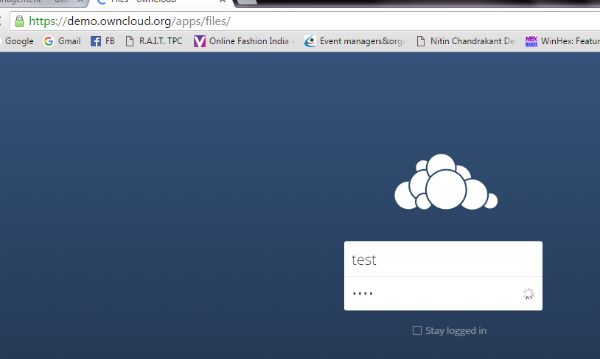

2. By default, the ownCloud Web interface opens to your Files page. You can add, remove, and share files, and make changes based on the access privileges set by you (if you are administering the server) or by your server administrator. You can access your ownCloud files with the ownCloud web interface and create, preview, edit, delete, share, and re-share files. Your ownCloud administrator has the option to disable these features, so if any of them are missing on your system ask your server administrator.

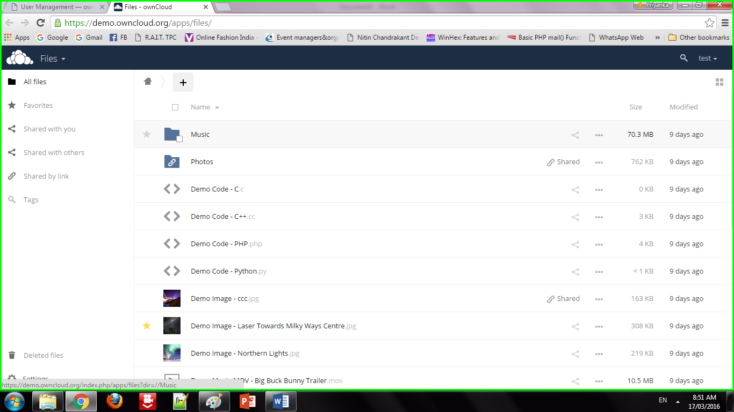

3. Apps Selection Menu: Located in the upper left corner, click the arrow to open a dropdown menu to navigate to your various available apps.

Apps Information field: Located in the left sidebar, this provides filters and tasks associated with your selected app.

Application View: The main central field in the ownCloud user interface. This field displays the contents or user features of your selected app.

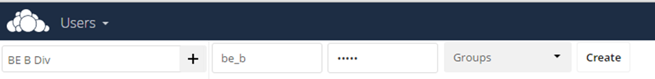

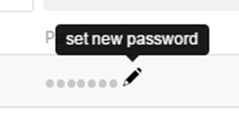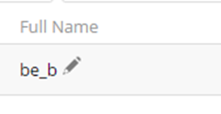

4. Share the file or folder with a group or other users, and create public shares with hyperlinks. You can also see who you have shared with already, and revoke shares by clicking the trash can icon. If username auto-completion is enabled, when you start typing the user or group name ownCloud will automatically complete it for you. If your administrator has enabled email notifications, you can send an email notification of the new share from the sharing screen.

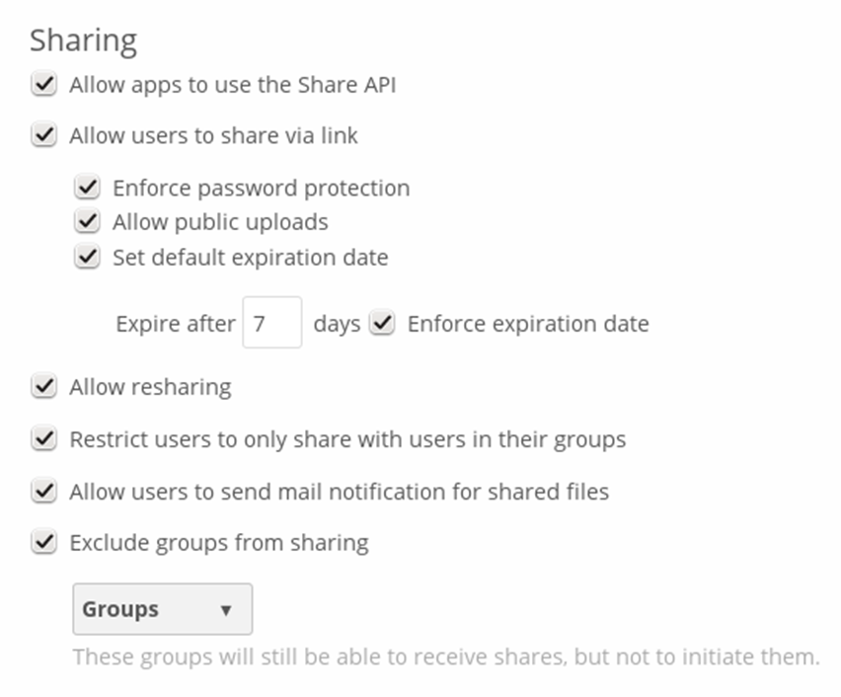

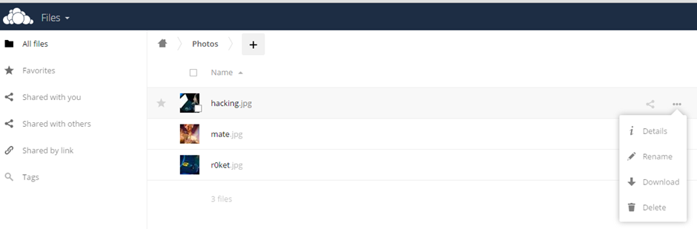

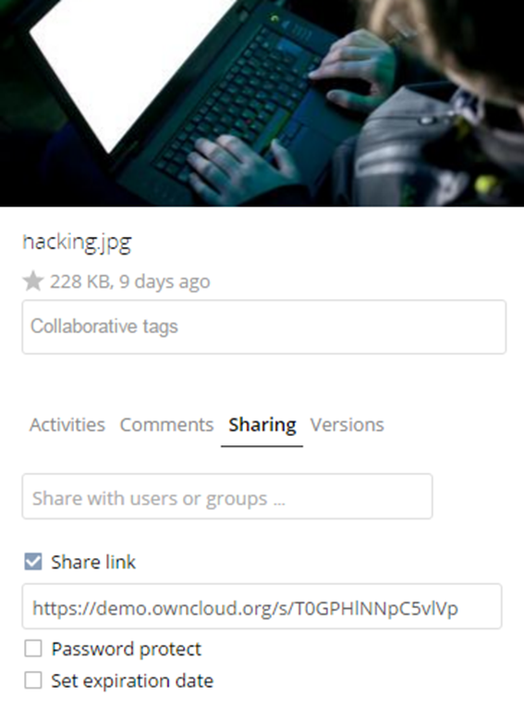

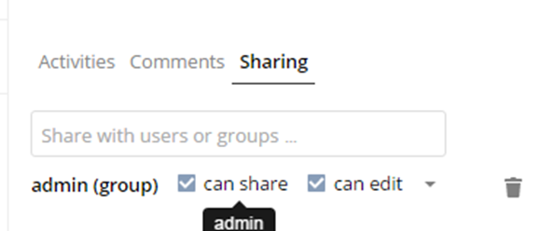

5. Five Share Permissions are:

1. Can share; allows the users you share with to re-share.
2. Can edit; allows the users you share with to edit your shared files, and to collaborate using the Documents app.
3. Create; allows the users you share with to create new files and add them to the share.
4. Change; allows uploading a new version of a shared file and replacing it.
5. Delete; allows the users you share with to delete shared files.

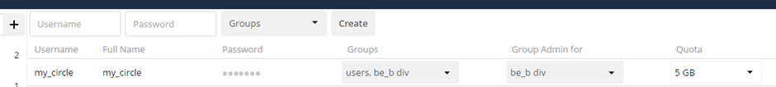



**Result :->**

This is how we can simulate identity management in your private cloud using ownCloud.

**Ex No. : 13 Date : 19/05/21**

**Experiment – 13**

**Objective :->**

Storage as a Service: To explore Storage as a Service for remote file access using web interface. Technology: Own Cloud

**Requirements :->**

ownCloud

**Theory :->**

Cloud storage is nothing but digital data stored in logical pools. The physical storage may span multiple servers (and even be placed at several locations) that are typically owned and managed by a specific server hosting company like Amazon or Google. All such cloud storage providers are responsible for keeping the stored data available and accessible. They also care for the physical environment where the servers are located, and ensure proper security and that the servers are always up and running. All those who intend to make use of the cloud, either individuals or an organisation, need to buy or lease storage capacity from the providers in order to store organisation or application data. Cloud storage services can be accessed using a co-located cloud computer service or a Web service API (Application Programming Interface). These can also be accessed with the help of different applications like Cloud Storage Gateway or cloud desktop storage systems that make use of APIs to interact with the cloud.

So why do we need to move towards cloud-based storage systems? Here are some of the factors that push us towards making such a choice:

**Flexibility**: Cloud based storage services are pretty good for businesses with fluctuating or growing demands. If your needs or requirements increase, then it’s easy to scale up your cloud capacity by drawing on the service’s remote servers. In the same way, if you need to scale down, then the flexibility of the cloud can help you scale down the number of servers. This level of agility can really give businesses using cloud-based storage systems a real advantage over their competitors.

**Free of Capital Expenditure**: Cloud computing helps you avoid the huge cost associated with the different hardware used as part of customary storage systems. You simply pay as you go and enjoy a subscription-based model. This lets you pay only for the memory that is being used. Also, there is no setup and management overhead associated with this subscription model.

**Automatic Software Updates**: The best part of cloud-based storage systems is that the servers are present off-premise and out of your sight. Suppliers providing the cloud-based storage services take care of different updates for you and continuously roll out regular software updates – including that for security. Hence, you need not worry about system maintenance. This leaves you free to focus on the things that matter, like growing your business.

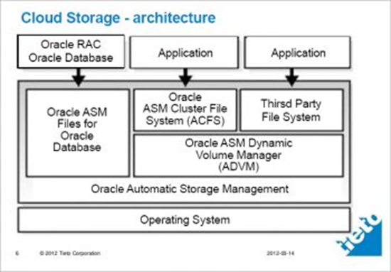

**Disaster Recovery**: Businesses of all sizes have to invest in robust disaster recovery, but this becomes really difficult and challenging for smaller businesses that are financially weak and lack the required expertise. The cloud helps all such small organisations avoid this problem. They don’t have to spend much on disaster recovery as the model of cloud-based storage systems is designed in such a way that it minimises the risks of disasters. According to the Aberdeen Group, small companies are twice as likely as big companies to have implemented the cloud-based backup and recovery solutions that help save time, avoid large investments and avail the third-party expertise as part of the deal.

**Work From Anywhere**: With cloud storage solutions, if you have an Internet connection, you can be at work. And with most of the cloud services offering mobile applications, you are not restricted by which device you have at hand. Hence, businesses can now offer their employees more flexible working hours so that they can enjoy a better work-life balance, without impacting the productivity.

**Increased Collaboration**: When your teams can access, share and edit documents anytime and from anywhere in the globe, then they are able to work together, better. Cloud based workflows and file sharing applications help you make updates in real-time and give others full visibility of their collaborations.

**Security**: If you lose your company laptop, it can become a billion-dollar business problem. More important than the loss of an expensive laptop is the loss of the sensitive data present in it. Cloud computing gives us greater security when such incidents happen. Because your data is stored in the cloud, you can access it no matter what happens to your machine. And you can even remotely wipe the data from lost laptops so that it does not get into the wrong hands.

**Document Control**: The more the number of employees and partners collaborating on any document, the greater is the need for watertight document control. Before the existence of the cloud, workers had to send sets of files back and forth in the form of email attachments so that they could be worked on by one user at a time. Sooner or later (usually sooner) you ended up with a really big mess of conflicting file formats, content and titles.

As even the smaller companies are becoming more global today, the scope for complications is rising. When you make the move towards cloud computing, all the files are stored centrally and everyone can see one version of the truth. Greater visibility means improved collaboration, which ultimately signifies better work and a healthier bottom line.

**Competitiveness**: Everyone looks for that one simple step that could make us more competitive. Moving to the cloud gives you access to enterprise-class technology, for everyone. It also allows different smaller businesses to act faster than the big and established competitors. Pay-as-you-go services and the cloud business applications show that small outfits can also run with the big boys, and can disrupt the market, while remaining nimble and lean.

**Environment-Friendly**: While all that we have discussed covers the benefits of cloud-based storage systems for your business, moving to the cloud is not actually a completely selfish act. The environment should get a little love too. When your cloud fluctuates, your server capacity scales up and down in order to accommodate fluctuating needs. So, you only use the energy you need and do not leave oversized carbon footprints.

**Procedure :->**

**Setting up your own private Cloud Storage Service using ownCloud ->**

There have been several reports of various cloud storage services getting hacked of late. Thankfully, you can actually create your own cloud storage solution that you can control with an open-source service called ownCloud. It is a simple way to set up your own syncing and Dropbox-like cloud storage system on your own server or website. It is robust, quick and easy to set up, and does not require much advanced technical knowledge. Let’s have a quick look at how you can set up a private cloud using ownCloud.

**Prerequisites:**

You do not really need much to get started with setting up ownCloud, but should have the following handy before you start.

**1. Any Web host that supports PHP5 and MySQL (or SQLite):** You should be signed up for a service like Dreamhost. If you already have a domain name (like http://www.name.com) through a Web host, you can install ownCloud in a couple of minutes. You will not have to deal with things like MySQL and PHP for installing ownCloud. All of these are taken care of automatically. You just need to make sure that your hosting service supports them.

**2. A copy of ownCloud Server 5:** You can actually install ownCloud in different ways, but let’s just stick to the simplest method, i.e., using the Web installer. If you know how to put a file onto your website, you can install this.

**3. A URL for Remote Access:** Since you would prefer to tap into ownCloud from anywhere, you will need a URL to do so. If you do not already have a domain name, you can buy one; but if you do, it’s very easy to set up ownCloud in a sub-directory of your site.

**Initial Setup and Installation ->**

As was decided earlier, we will use the Web installer, with the help of which ownCloud automatically creates everything you need so that no special skills are required to get it set up. If you have multiple users wanting to access ownCloud, it is recommended that you manually create a database.

Here is how you can install ownCloud using the Web installer :

1. Download and save the Web installer to the computer.

2. Upload the setup file – owncloud.php – to the Web space using the host’s Web interface or an FTP application.

3. Enter the URL of the setup file into the Web browser. It should be something like <http://www.yourdomainname.com/setup-owncloud.php>

4. Follow the given on-screen instructions to install ownCloud. After a few minutes, you will be redirected to the login page.

**Setup for Desktop and Mobile Sync ->**

Now that you have ownCloud installed on your Web server, it’s time to set up desktop sync so that the files in ownCloud are the same format as those on your computer. For this, you need to install the desktop client (Linux, Windows or Mac).

From here onwards, the setup is pretty simple :

1. Open up ownCloud software on the computer, and select Configure.

2. Add the URL of the ownCloud server along with the login credentials.

3. Now, you need to select the folders and files that you want to sync. Click Add folder and select a folder that needs to be synced on the computer. All the files present in this folder will be uploaded and synced automatically to ownCloud. Similarly, you can add as many folders as you like.

As with Dropbox, you can simply drag files into the Web interface so that they can be uploaded and synchronised both locally as well as in the cloud, and you can also share files with friends by selecting the Share option when you hover the mouse over a file.

**Syncing the Calendar and Contacts ->**

**Syncing Calendar**: If you use a calendar app that supports CalDAV, you just need to point it to your ownCloud installation.

1. Click the Calendar icon on the right side.

2. Click the gear icon present in the top right.

3. Copy down the URL for the calendar (most of the calendars can access simple URLs, but iOS requires a slightly different URL).

4. Now, simply open the settings of your favourite calendar app, and add your account in the CalDAV section. All your appointments will be directly dumped into ownCloud and will be automatically synced across any other device you connect to it.

**Sync your Contacts**: Similar to the calendar, you can easily import and sync your address book with ownCloud.

1. Export all the Contacts from the address book into a VCF file.

2. From ownCloud, select the Contacts sidebar, and then click the gear present in the bottom left corner.

3. Click Import and then select the VCF file to be uploaded.

It will take a few minutes to get all the contacts uploaded, but once they are up, you can synchronise them with any address book that supports CardDAV.

**Add apps and extend ownCloud’s power ->**

It is even possible to extend ownCloud’s functionality with the help of additional applications. If you click your user’s name from the ownCloud Web interface and select Apps, you are taken to a list of the installable applications. You can also browse through a few more such applications over here. To install any of the external applications, you just need to select the app, and click Enable. After a few moments, it will be installed and you will find a new icon on the right panel.

The benefits of setting up your own cloud storage system are many, some of which are:

1. It helps to access the data present on the cloud from anywhere; hence, it’s flexible.

2. It is highly scalable.

3. As it is a private cloud, it has got higher security.

4. It is easy to sync files from your desktop to the cloud.

5. It enables you to sync ownCloud with almost any desktop or mobile calendar and contacts application.

**Result :->**

This is how we can explore storage as a service for remote file access using web interface and ownCloud.

**Ex No. : 14 Date : 29/05/21**

**Experiment – 14**

**Objective :->**

Platform as a Service: To Deploy web applications on commercial cloud. Technology: Google App Engine

**Requirements :->**

GitHub account and Google Cloud account

**Theory :->**

Google App Engine (often referred to as GAE or simply App Engine) is a cloud computing platform as a service for developing and hosting web applications in Google-managed data centers. Applications are sandboxed and run across multiple servers. App Engine offers automatic scaling for web applications—as the number of requests increases for an application, App Engine automatically allocates more resources for the web application to handle the additional demand.

Google Cloud Platform (GCP) is a suite of cloud computing services provided by Google. It is a public cloud computing platform consisting of a variety of services like compute, storage, networking, application development, Big Data, and more, which run on the same cloud infrastructure that Google uses internally for its end-user products, such as Google Search, Photos, Gmail and YouTube, etc.

The services of GCP can be accessed by software developers, cloud administrators and IT professionals over the Internet or through a dedicated network connection.

The App Engine SDK allows you to run Google App Engine Applications on your local computer. It simulates the run-‐time environment of the Google App Engine infrastructure.

**Procedure :->**

1. First go to Firefox or any other browser and search google cloud platform as shown below.

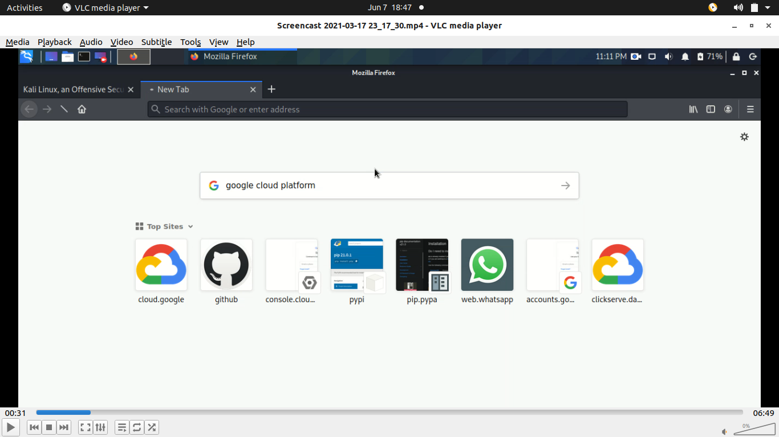

2. Now results come now click on cloud console on your official site. Now to create a project go to my first projects navigation menu and click it just as shown below.

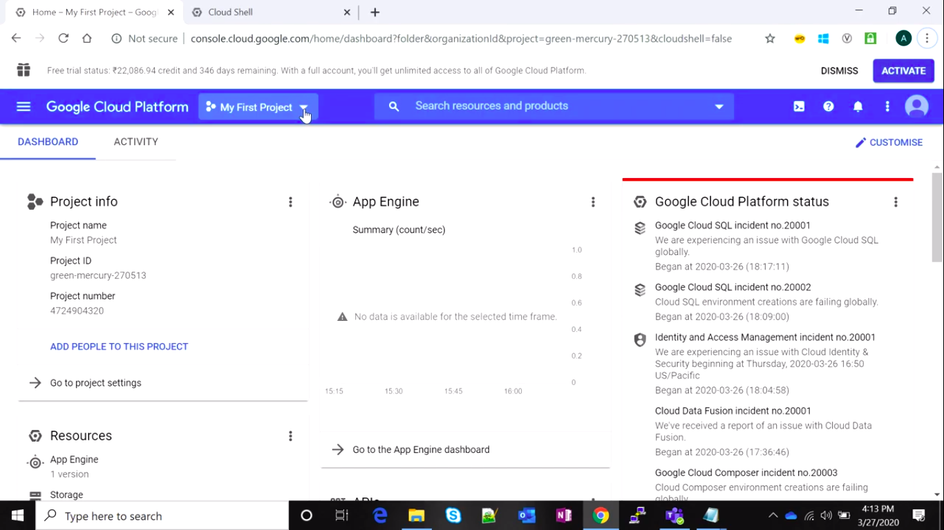

3. Now again a page comes where your previous projects shown, we have to create a project (if you not create it and want to create), so go to new project and now a new page comes.

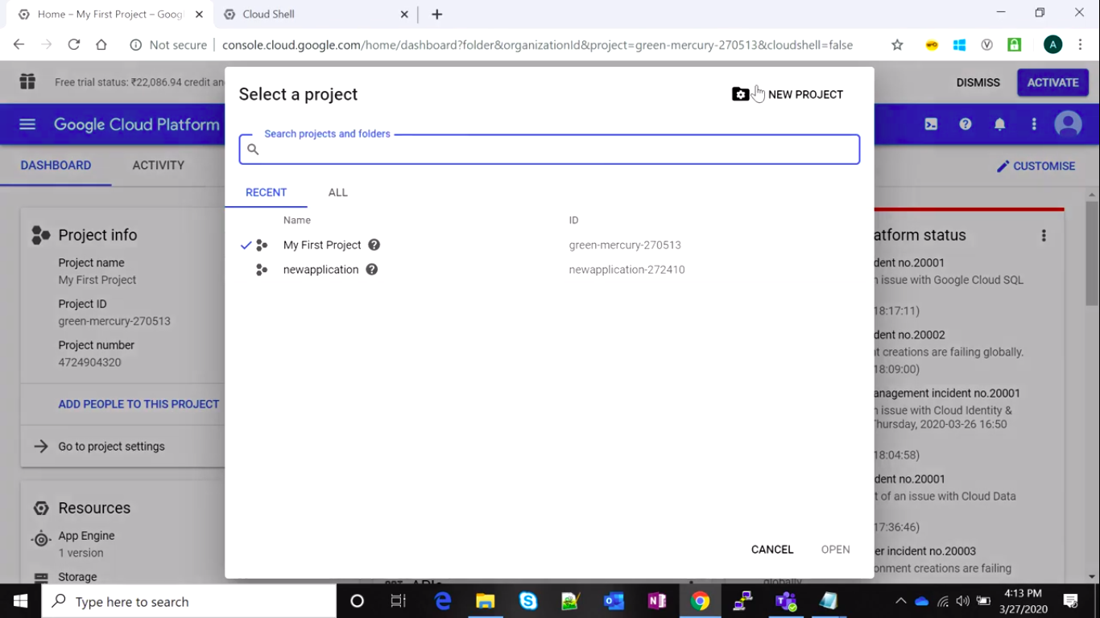

4. Now give name to your project what you want and click on Create icon.

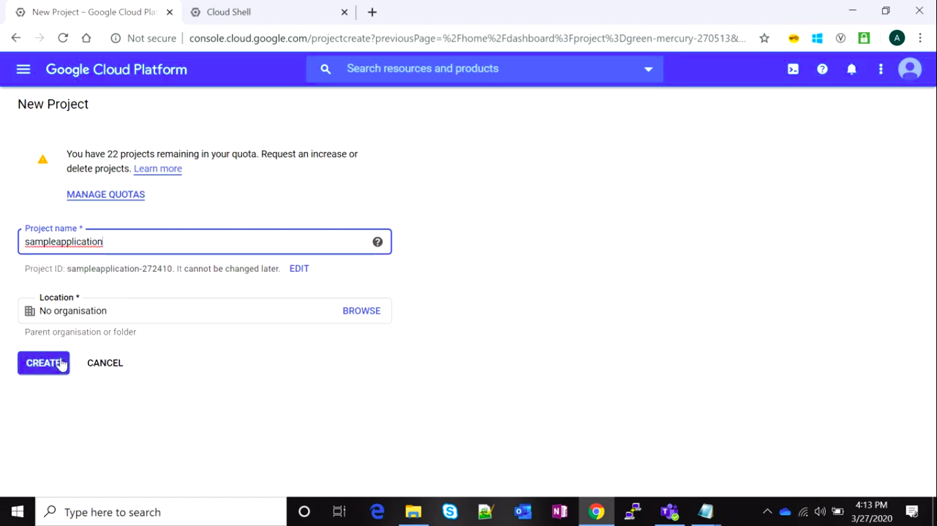

5. Now to see our project has been created so go again on my first projects navigation menu and click it there you see your projects has created.

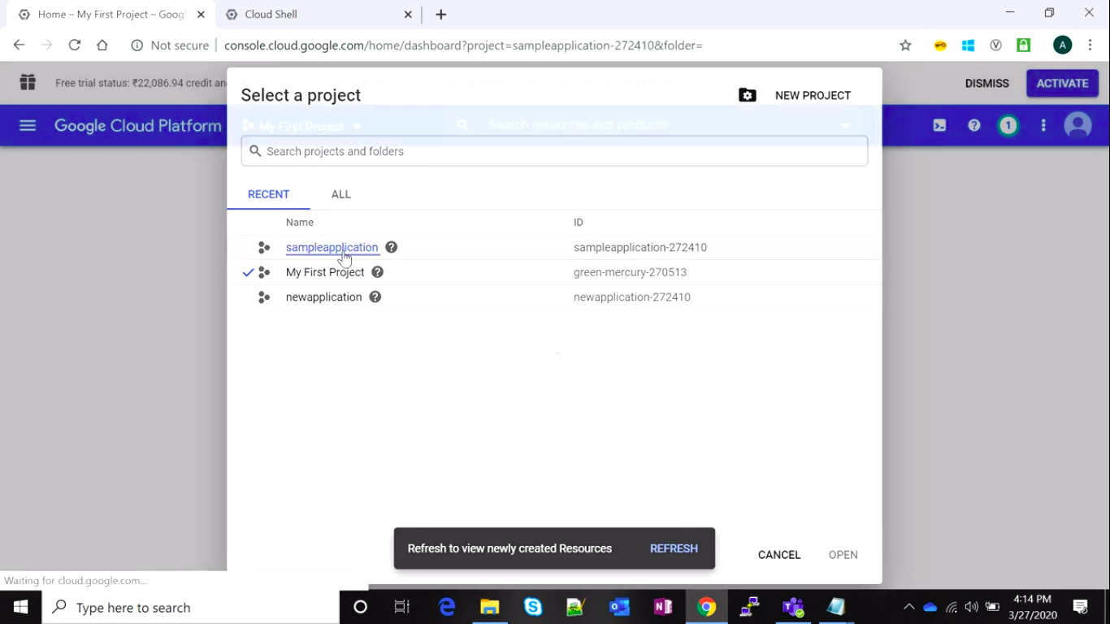

6. Now to verify it you can go terminal navigation bar as we do in experiment4 and on terminal type gcloud projects list there you see your all projects.

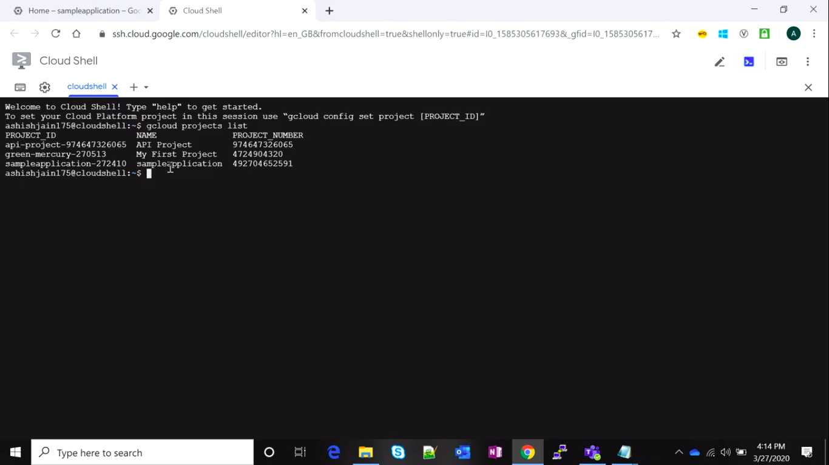

7. Now go leftmost navigation icon and click on it you will get a lot options and go to APIs & Services.

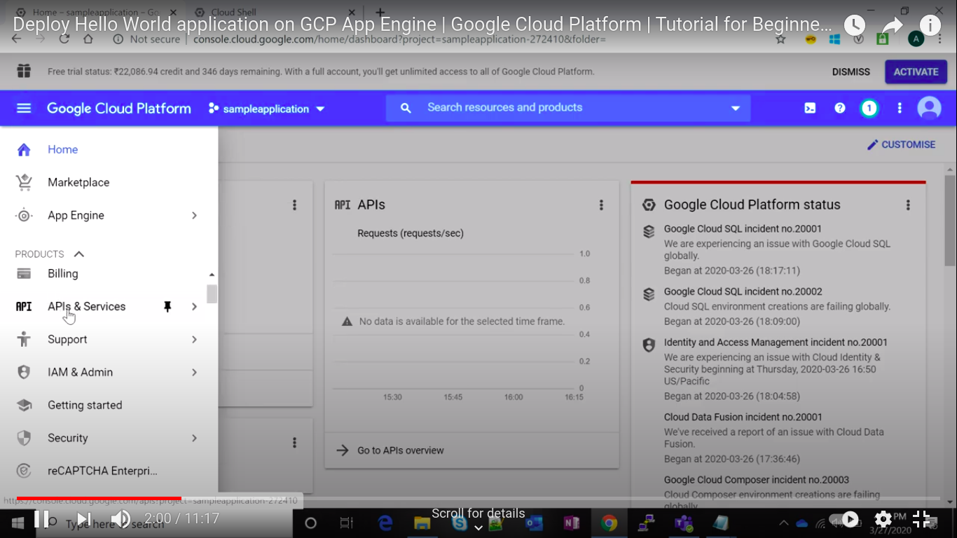

8. Now you see a page just as shown below now we have to enable the APIs & Services to do that we have to go the + ENAVLE APIS AND SERVICES as shown in figure.

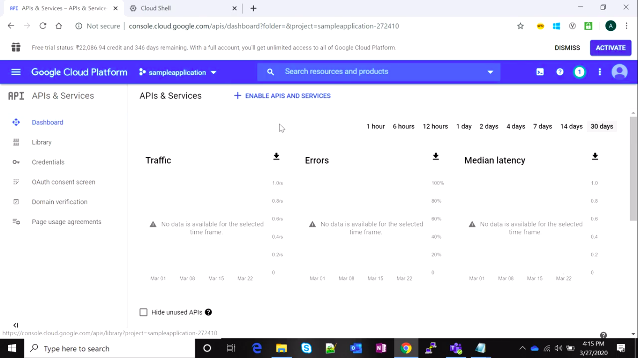

9. Now on top of page you have to go search and type app engine you find some options there click on App Engine Admin API to enable it.

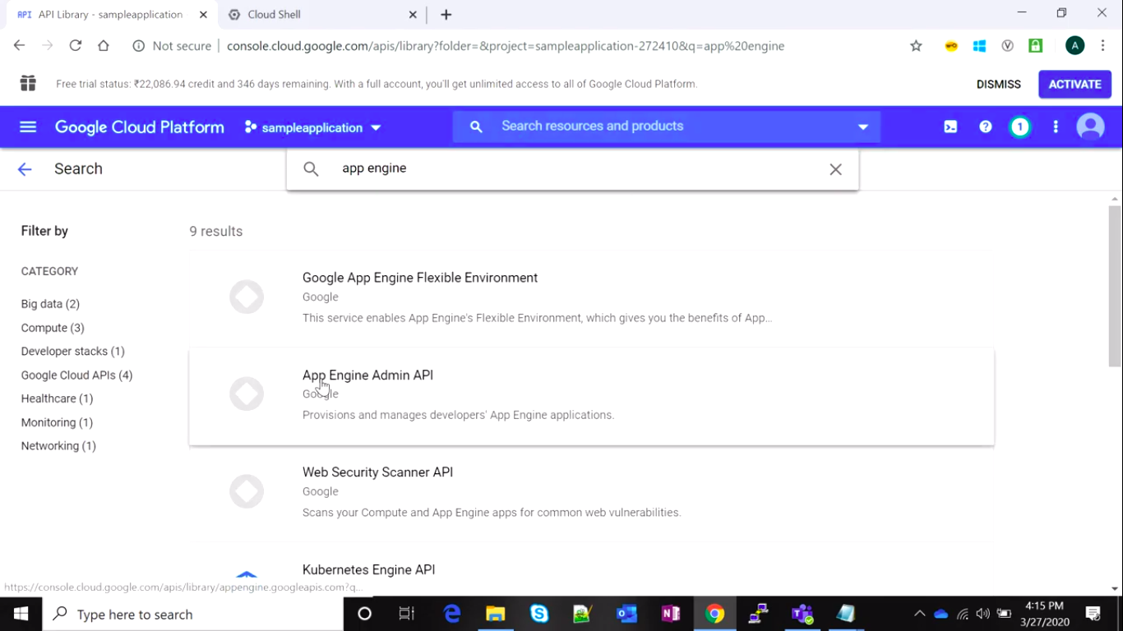

10. Now on this click on enable. So that our app engine gets started.

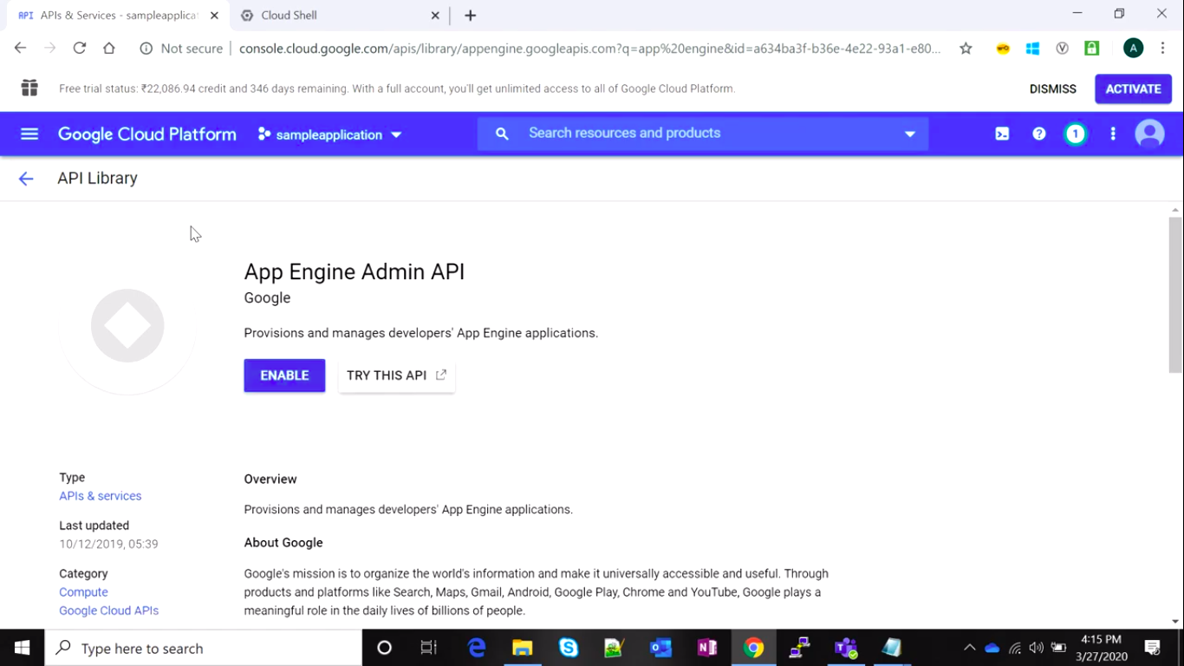

11. Now open your terminal again and type gcloud config set project project_name just as shown below.

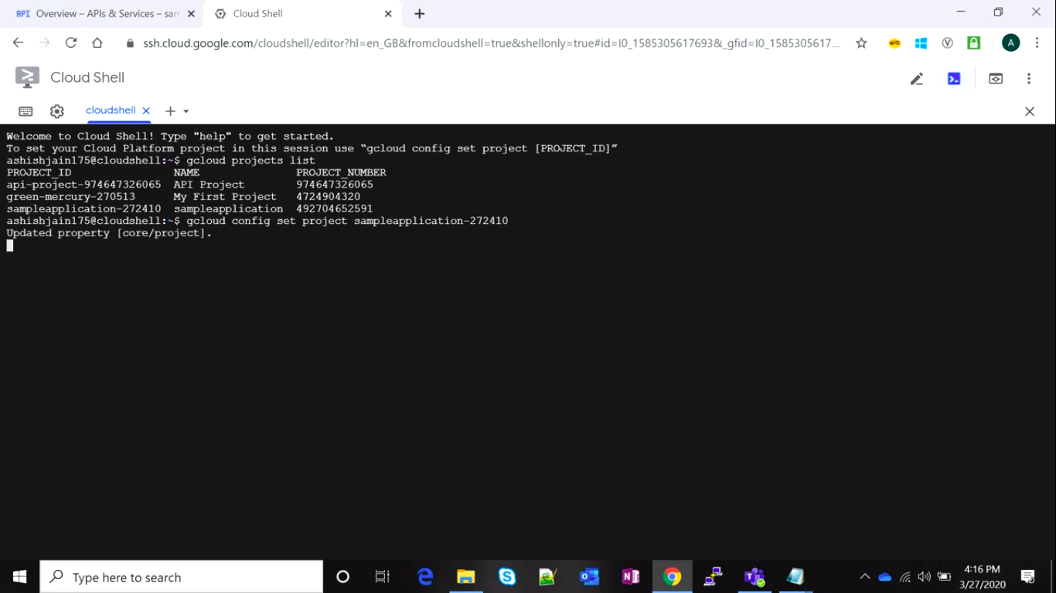

12. Now go on App Engine there you get some options now click on Dashboard.

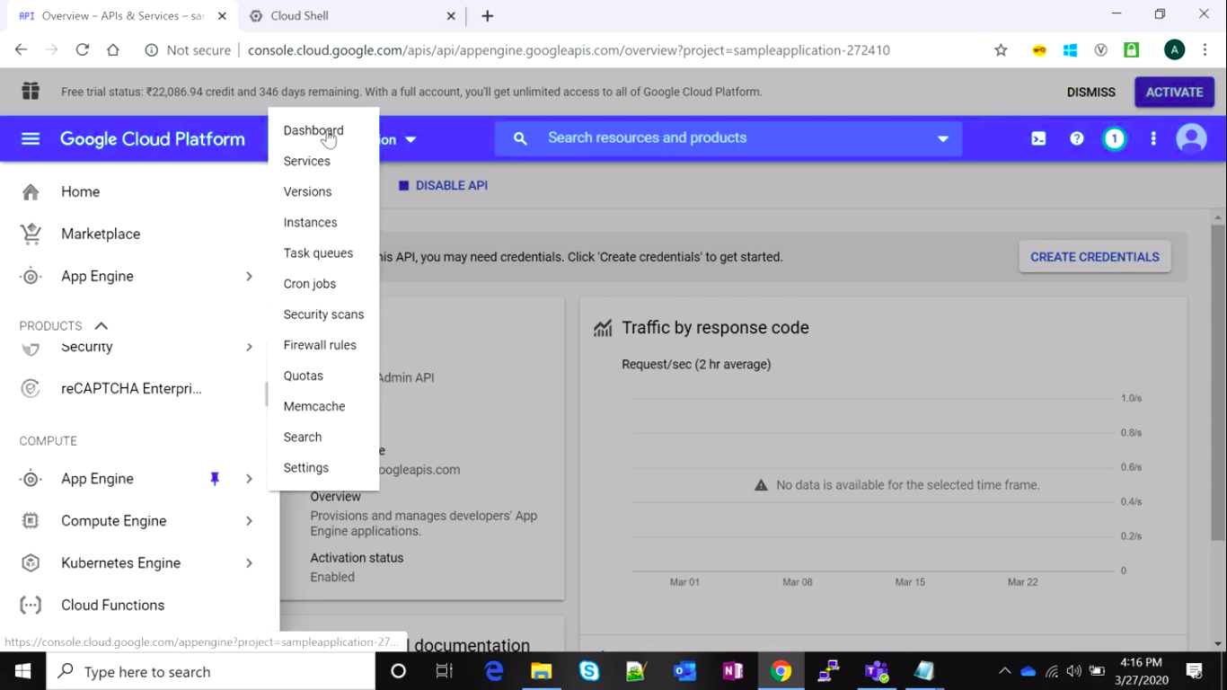

13. Now a page comes where you see an icon of create application click on it.

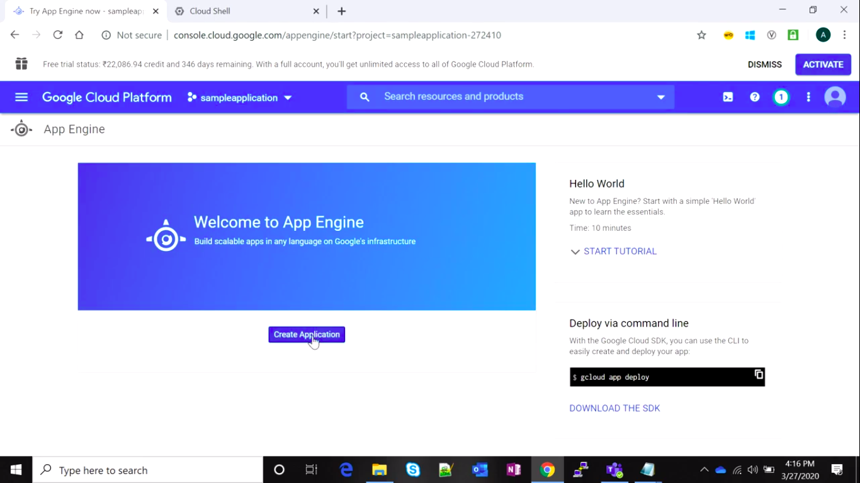

14. Now go again to terminal and type gcloud app create you get notification in terminal like shown below now it will ask you the which option you want to choose for App Engine location choose which one you want.

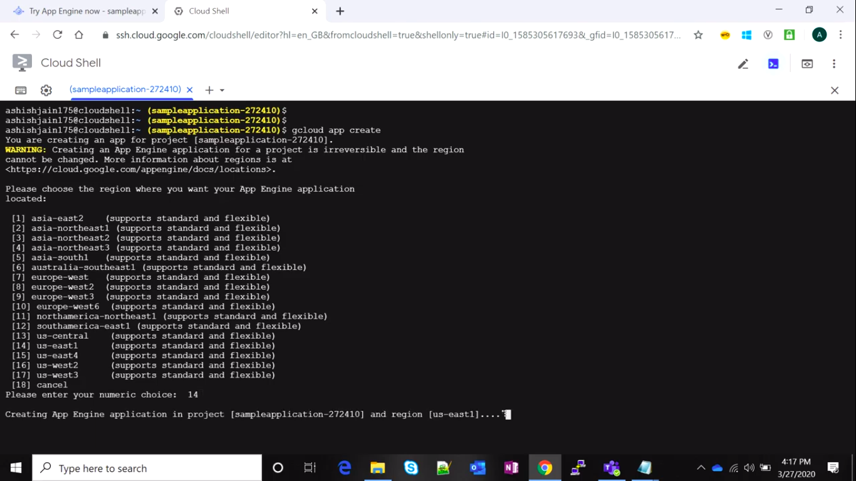

And you screen will be shown as below.

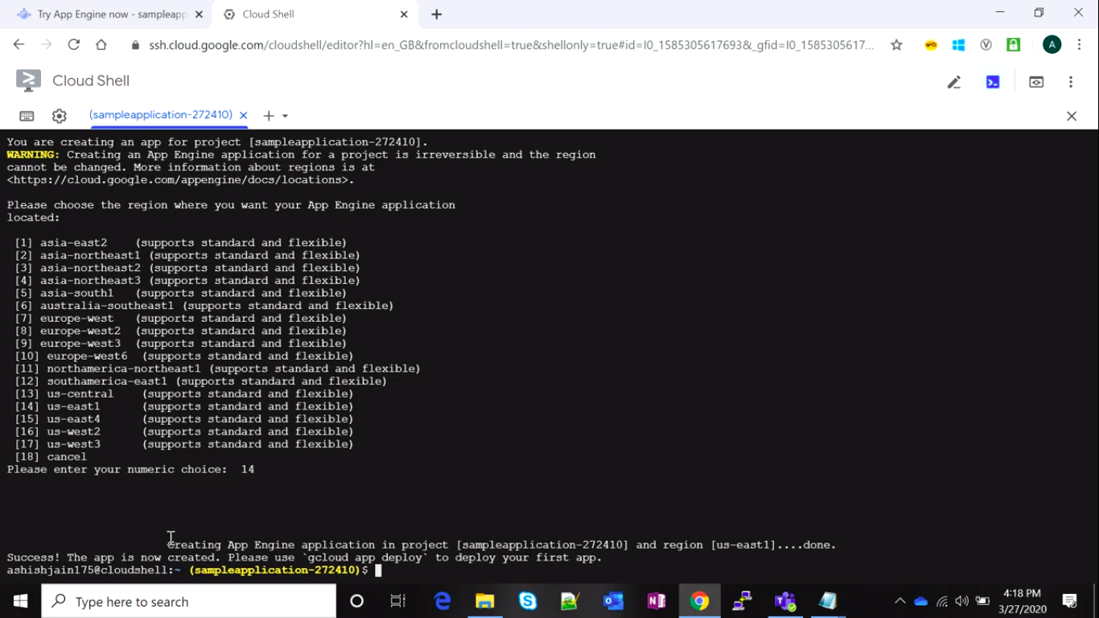

15. Now if you go again on app engine option and check dashboard you will get your app engine application is created.

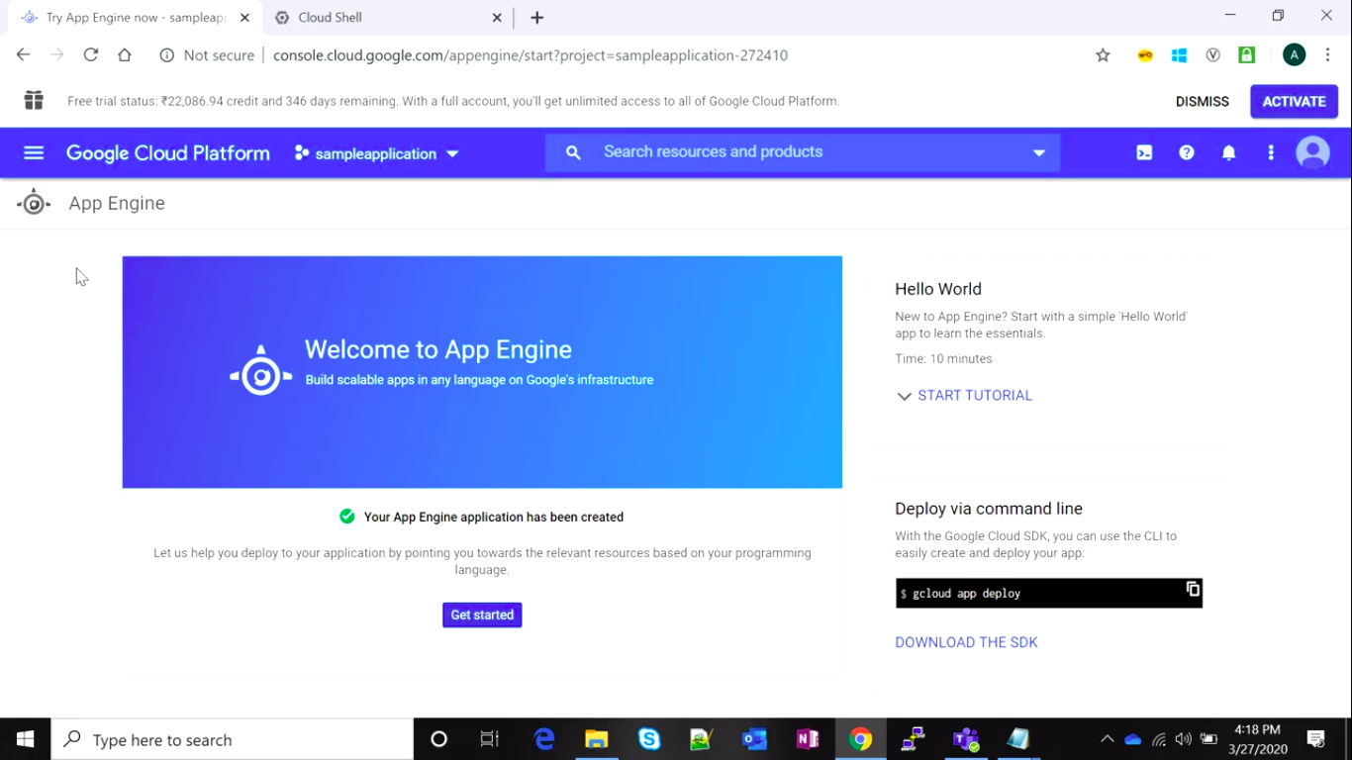

16. Now to create application type git clone https://github.com/GooglrCloudPlatform/python-docs-sample. Actually, this is a repository made by google.

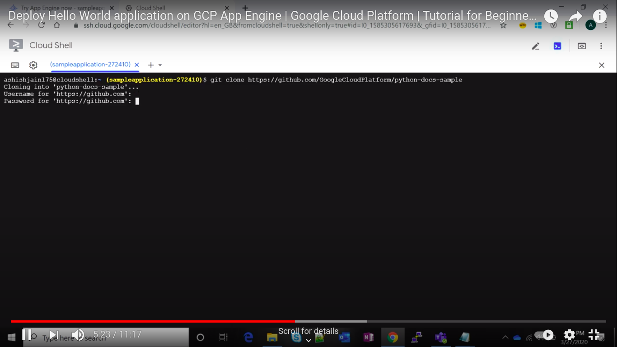

17. now we can see what is inside of this repository to do that type ls to get list of all files inside of this repository now to go python-docs-sample type cd python-docs-samples/ now go to appengine folder by using command cd appengine/ and press enter, you will see some files now we go to standard python file so again type cd standard_python3.7 and now type ls to see files inside of it we find there a helloworld file so again type cd Hello_world.

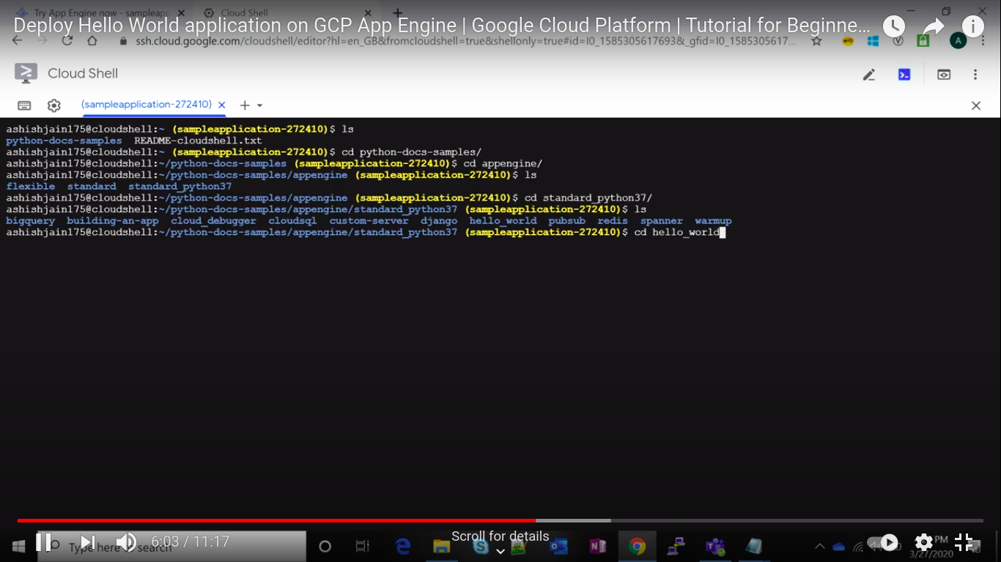

18. Now after arriving new terminal type gcloud app deploy app.yaml and hit enter you get URL where your application is hosted. Now to continue this press Y and wait a little.

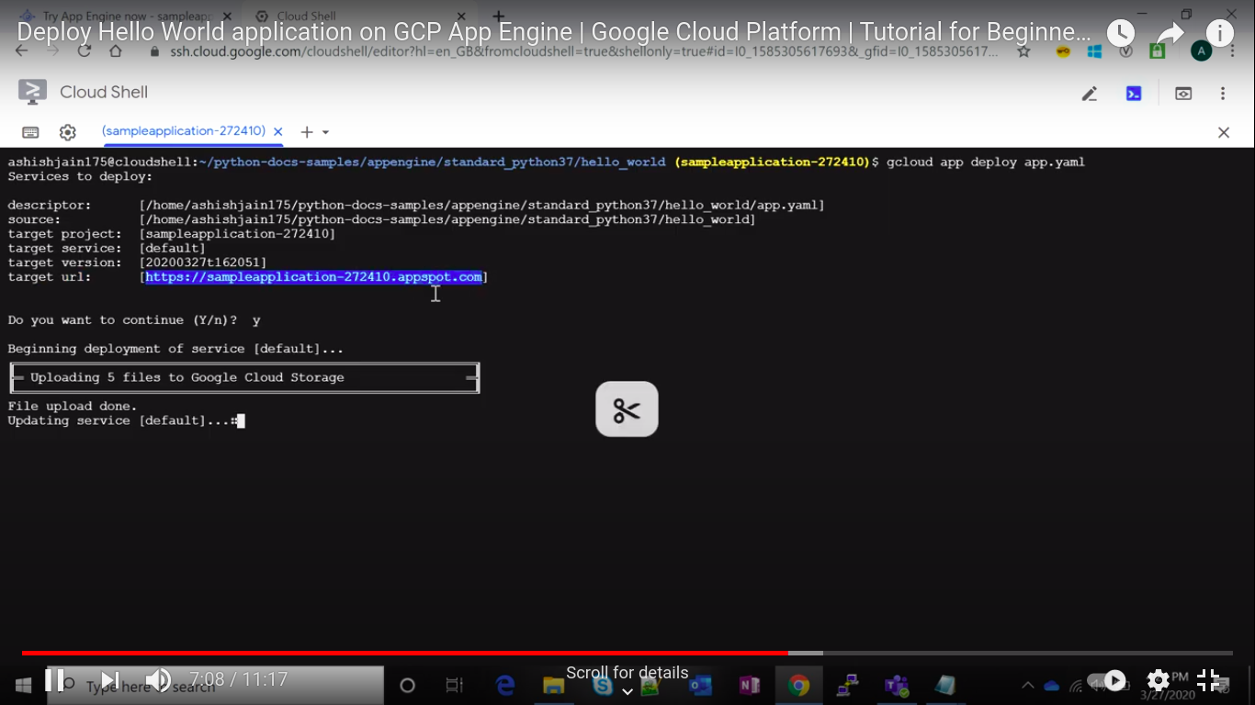

19. Now to view application type gcloud app browse so that is will give URL of your application.

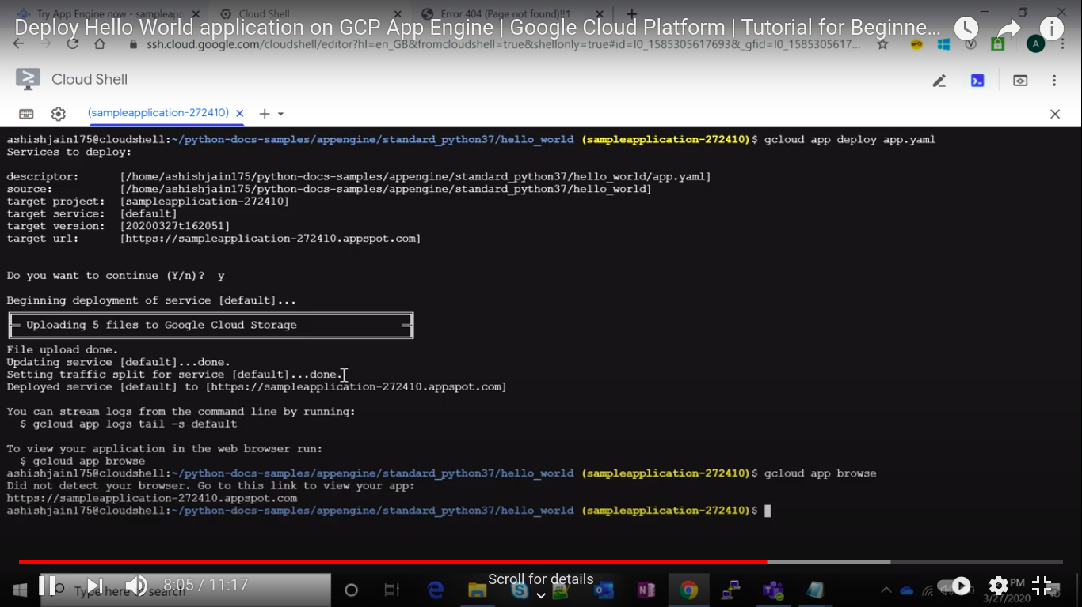

20. Now paste URL on top of browser and press enter you will get your application works.

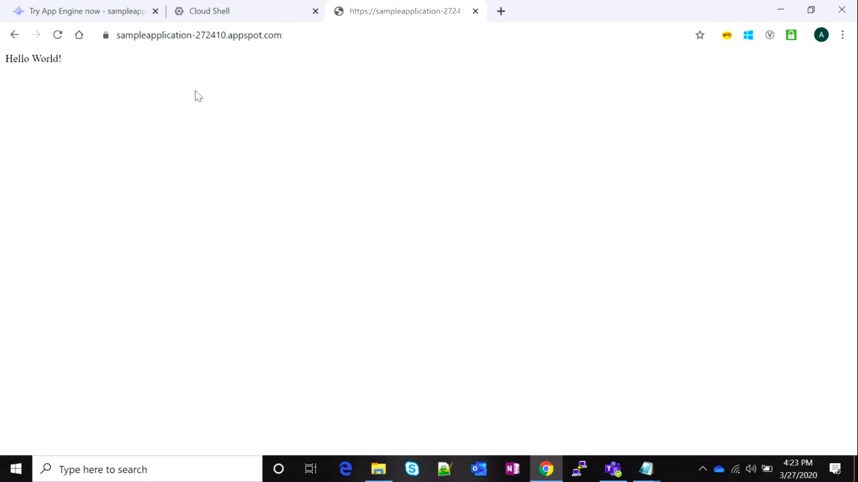

**Result :->**

This is how we can deploy web applications on commercial cloud using Google App Engine.

**Ex No. : 15 Date : 02/06/21**

**Experiment – 15**

**Objective :->**

Amazon Web Service: To create and access VM instances and demonstrate various.

**Requirements :->**

Amazon Web Services, Any Laptop

**Theory :->**

**Amazon Web Services:**

Amazon Web Services (AWS) is a subsidiary of Amazon providing on-demand cloud computing platforms and APIs to individuals, companies, and governments, on a metered pay-as-you-go basis. These cloud computing web services provide a variety of basic abstract technical infrastructure and distributed computing building blocks and tools. One of these services is Amazon Elastic Compute Cloud (EC2), which allows users to have at their disposal a virtual cluster of computers, available all the time, through the Internet. AWS's version of virtual computers emulates most of the attributes of a real computer, including hardware central processing units (CPUs) and graphics processing units (GPUs) for processing; local/RAM memory; hard-disk/SSD storage; a choice of operating systems; networking; and pre-loaded application software such as web servers, databases, and customer relationship management (CRM).

The AWS technology is implemented at server farms throughout the world, and maintained by the Amazon subsidiary. Fees are based on a combination of usage (known as a "Pay-as-you-go" model), hardware, operating system, software, or networking features chosen by the subscriber required availability, redundancy, security, and service options. Subscribers can pay for a single virtual AWS computer, a dedicated physical computer, or clusters of either. As part of the subscription agreement,[10] Amazon provides security for subscribers' systems. AWS operates from many global geographical regions including 6 in North America.

**Procedure :->**

1. Go to aws.amazon.com

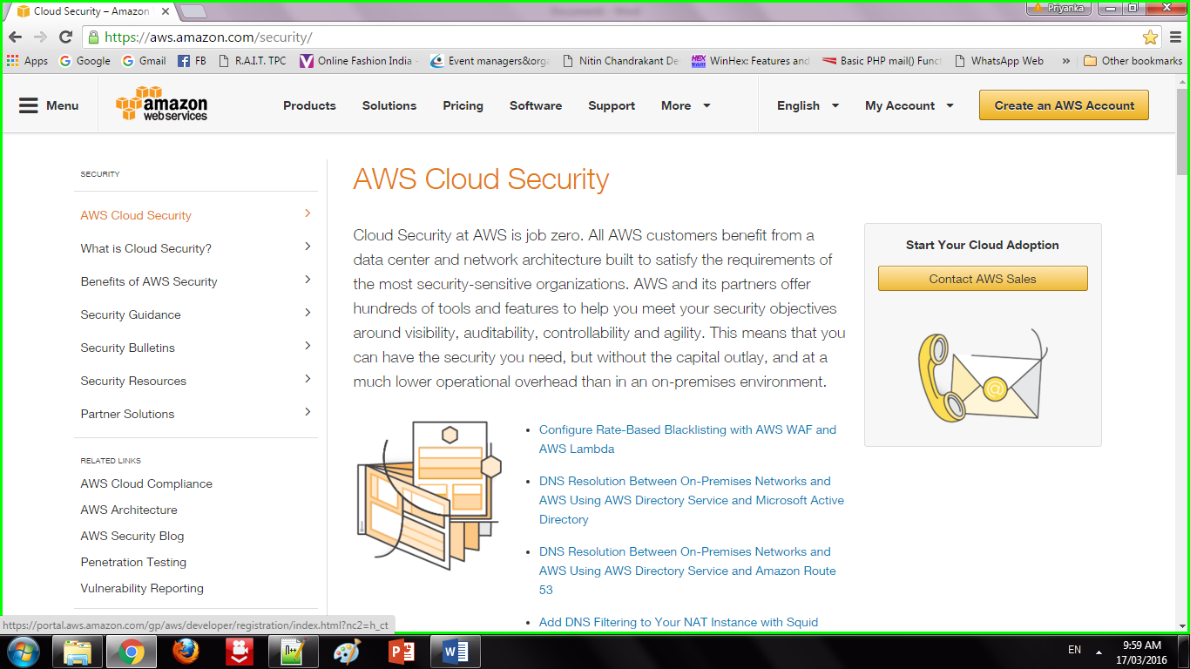

2. Click on "My Account". Select "AWS management console" and click on it. Give Email id in the required field

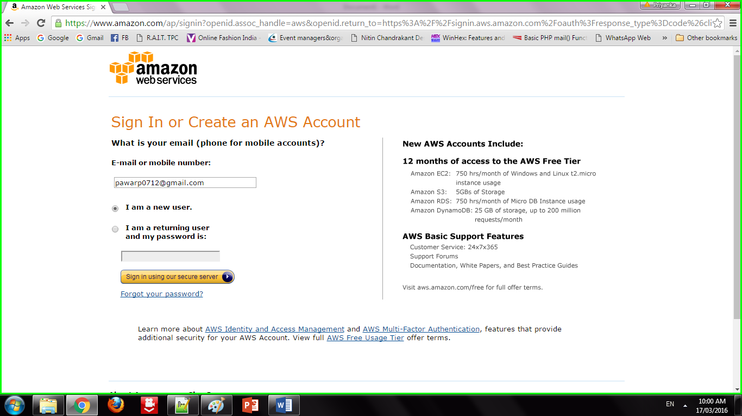

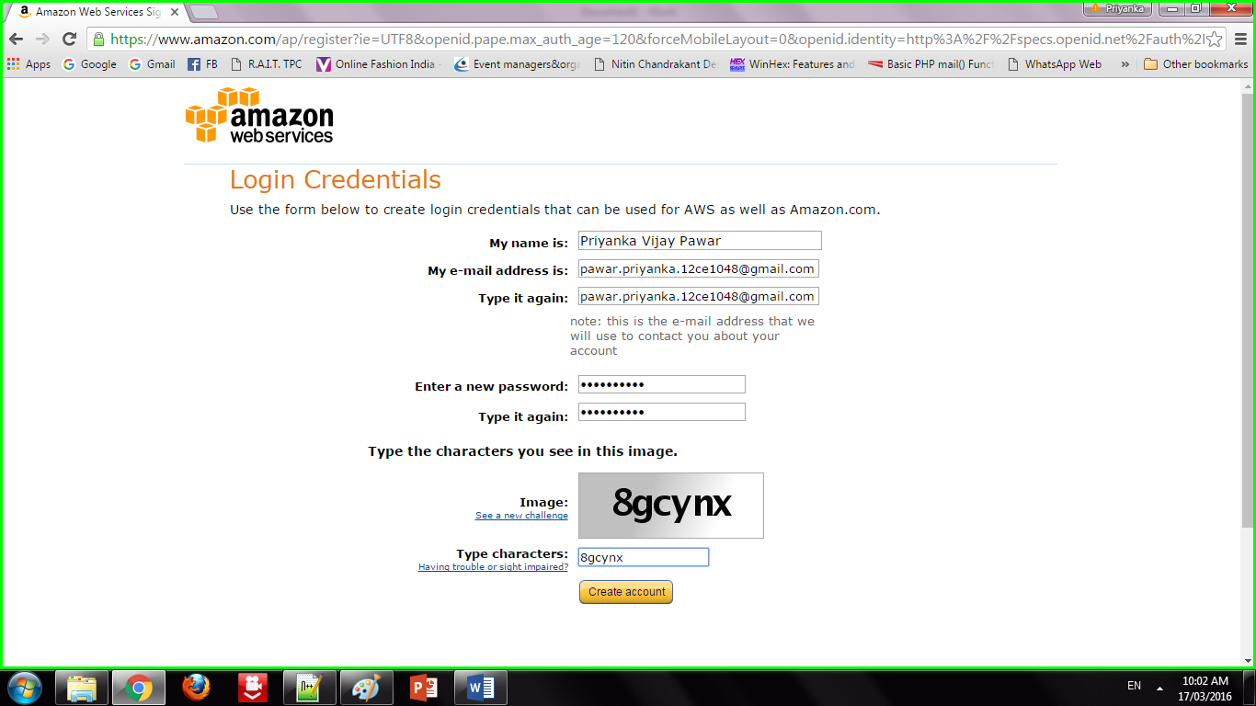

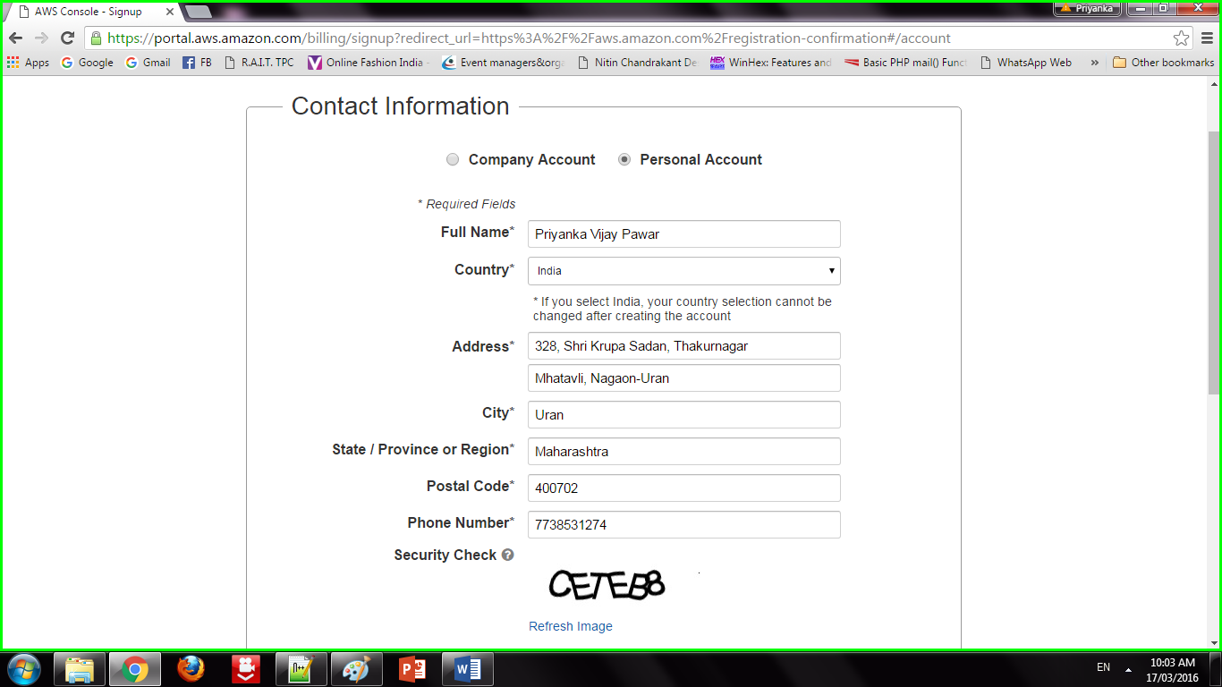

3. Addition of Security Features

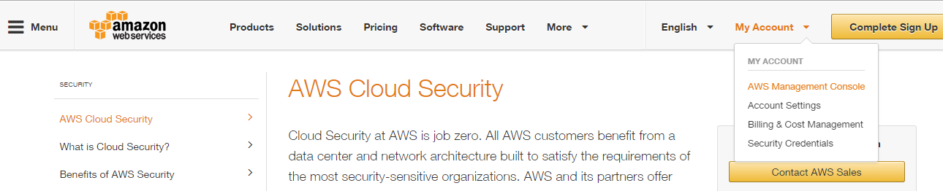

4. Sign in to an AWS account

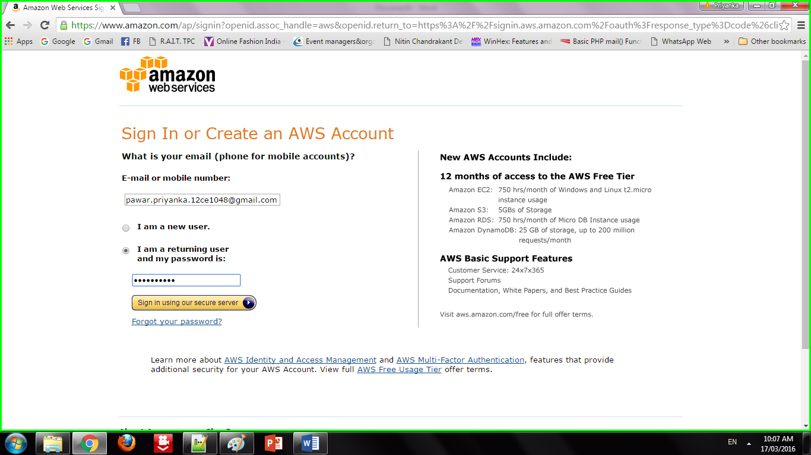

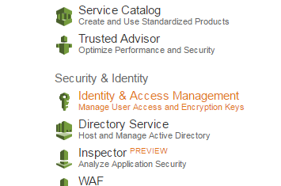

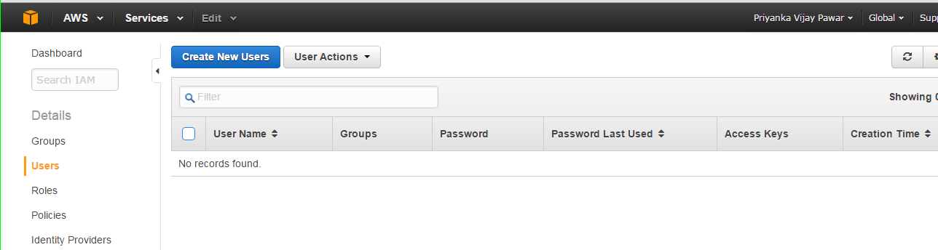

5. Creation of Users

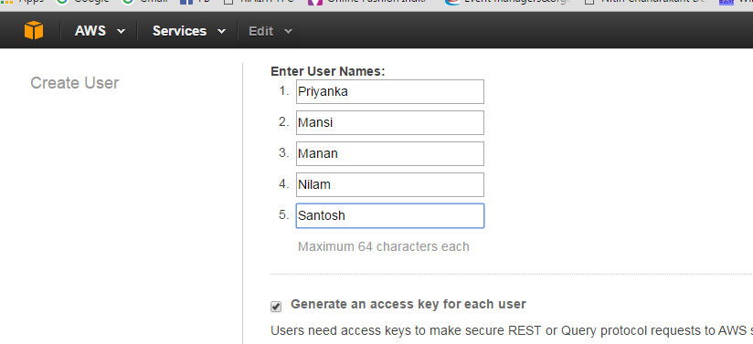

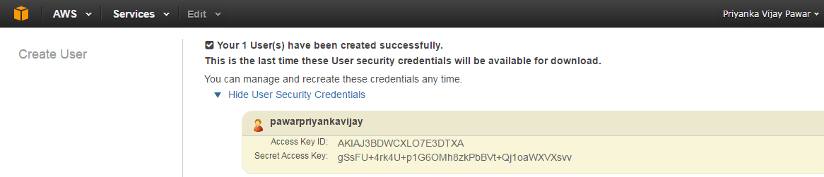

6. Adding Users to Group

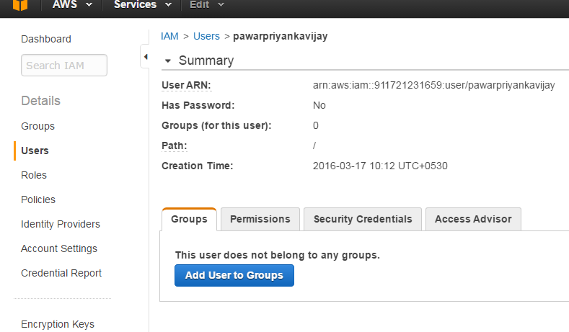

7. Creating Access Key

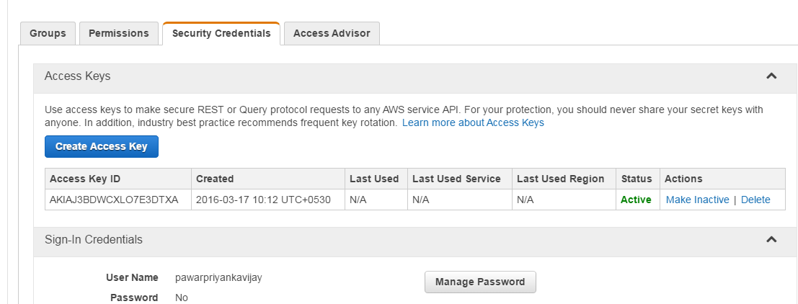

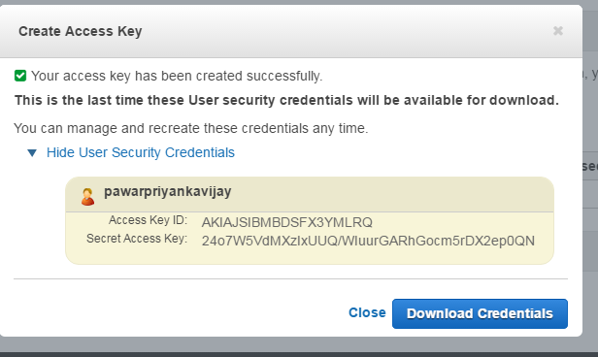

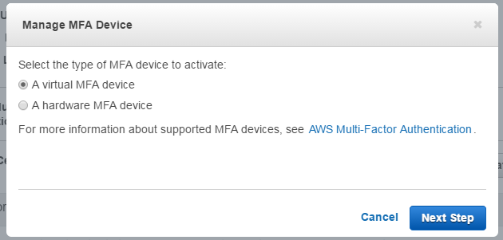

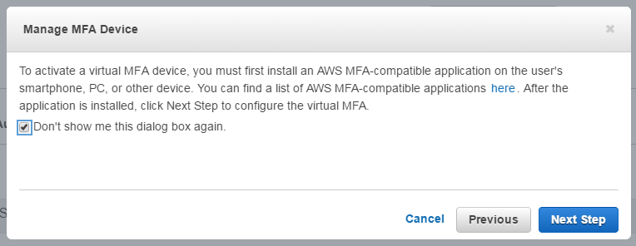

8. Setting Permissions to Users

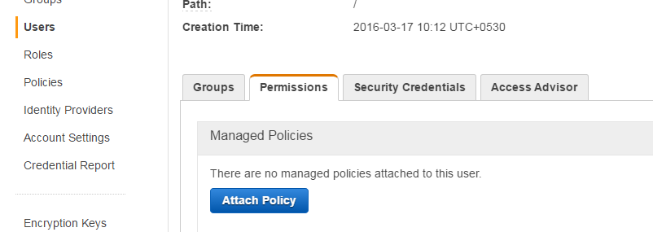

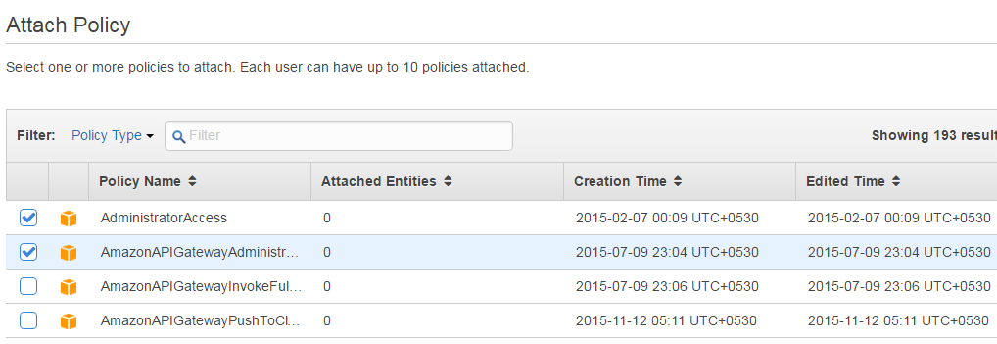

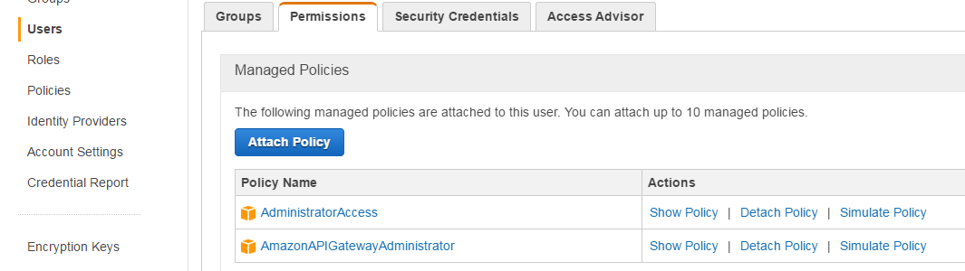

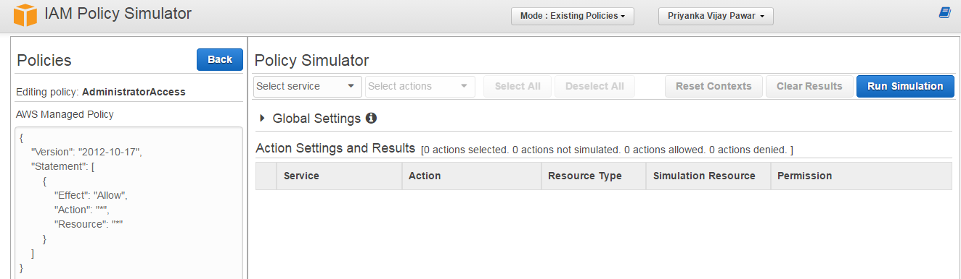

**Result :->**

This is how we can create and access VM instances and demonstrate various in Amazon Web Services.